Sample Lesson 1 - Comparatives 1

Name: _______ ___________ Date: _____________________ Teaching time: _45 min_
Action points – (These are the suggested techniques/ideas to try in your next practice teaching. See trainer’s observation notes from your last practice teaching session and copy the action points here)
1. Include materials to keep Ss interest on the lesson.
2. Include an activity which has an ‘authentic purpose’ in using the TL.

- What are you teaching?
Language points – speaking (writing, listening)
- Language skills – Comparative statements and questions (“X is ____er than Y” / “Is X ____er than Y?”)
- Cultural Aspects –

2. What are your Student Learning Objectives for the lesson? (These should be specific and describe observable student behaviors, which you will be able to see in class.)

By the end of the lesson, SWBAT:

make statements about and ask basic questions using comparatives (i.e. “x is taller than y” and “is x taller than y?”) by conducting a class survey about famous people.

3. When/How in the lesson will I check students’ progress toward the above Learning Objectives? What behaviors/activities will show me whether they have mastered the material? At the end of the lesson when Ss are able to ask and answer their own questions in the survey.

Preliminary considerations:
a. What do your students already know in relation to today’s lesson?
Most students will be familiar with adjectives used to describe people, suck as big, small, tall short, etc...
b. What aspects of the lesson do you anticipate your students might find challenging/difficult?
Using adjectives to compare two things may be completely new language for some Ss.
c. How will you avoid and/or address these problem areas in your lesson?
I will provide lower level Ss with opportunities for peer learning; for example new learners will have a chance to model their language use after the more experienced students.

Steps | Stages | Time (min): Guess here | Procedure/Steps--these need to be written in the perspective of what the students do | Focus  S-S, T-S, etc. | Activity Purpose
1 |  | 1 | - Greet Ss, introduce my name, smile, make eye contact, ask a few questions: What’s the weather like today? or Who’s your favorite singer?  - Introduce topic: Today we are going to talk about people? Do you like to talk about people? Do like 비? Do you like Ivy? | T-Ss | - Establish rapport, friendly atmosphere.  - Get Ss used to English and my voice / pronunciation.  - Intro of topic
2 |  | 7 | REVIEW / BRAINSTORM  - pics of tall, old pretty – elicit vocab from ss, write list on whiteboard (If Ss give non-adj. write on WB in different column);  - Ss in pairs create longer list  - if not on their list, add good, beautiful… | T-Ss  S-S  (T-Ss) | - Model task  - Activate Ss background knowledge, find out what Ss know, get an idea of Ss level.  - Validate Ss participation and build confidence in the topic
3 |  | 5 | PUZZLE GAME  - Logic puzzle on PPT and handouts. Small groups / pairs to discover names of the people in the picture based on clues:  - Cindy is taller than Alice.  - Jane is taller than Cindy.  - Mary is older than Alice.  - Jane is happier than Alice.  - Cindy is more intelligent than Jane.  - Mary is prettier than Cindy.  - Cindy is older than Jane.;  - feedback: elicit names  - elicit/give Ss structure: A is ____ than B  - erase / take away clues – drill: Ss make 3 sentences | T-S  S-S  T-Ss | - Ss first exposure to target language  - discovery method – Ss see the meaning of target language in a context, work out the rules from the examples.  - Student motivation / interest – Ss are initially focused on a meaningful task, NOT the language.
6 |  | 5 | Next Chunk – Q Form  Introduce/Elicit the questions form (assuming that some Ss are already familiar with this form): Is A _____ than B?  Use picture to drill: Have Ss make three Qs and ask them to each other – Ss then ask Qs to T  Picture as prompt and WB as support when pairs practice Q and A | T-Ss  S-S  S-T | Values Ss as experts;  Encourage Ss to participate in meaning making by providing learning materials.  Another chance to practice TL.

4 |  | 4 | CHECKING FORM  - T models chart on WB…check rules by asking Ss CCQs  - Ss complete chart on handout  - T monitors, checks answers | Ss  T-Ss | Ss are given a chance to produce the written form;  Visual/Tactile/Kinesthetic learners accommodated.
5 |  | 5 | LESS CONTROLLED PRACTICE  Show pictures/elicit names of famous Korean pop singers/movie/sports stars and write on WB  - model activity: T / T-Ss / Ss-T / Ss-Ss  A: Is A _____ than B?  B: Yes, A is ___ than B // No, A isn’t ____ than B.  - Ss practice asking and answering using pictures prompt or WB to scaffold task. TL support is provide as a gapped dialog. T can remove TL support to check if Ss have internalized | T-Ss,  S-S | Ss are given a chance to practice in a less controlled exercise;  Increase Ss interest by using relevant material.
7 |  | 8-10 | SURVEY  - Remove TL support  - Handout survey sheet  - Ss write 3 to 5 Qs about famous Koreans  - T models task with Ss  - Ss mingle with classmates and ask Qs and record As (T can have Ss form two lines, if it seems Ss aren’t mingling. Have the two lines face each other and have lines move in opposite directions to change partners)  - If time T models how Ss can report findings: Gina thinks BoA is more beautiful than Ivy.  . | T-Ss  S-S  S-S  T-Ss | Students are able to be active in their own learning;  The activity provides an authentic purpose in using the TL: to find out about the opinions of other classmates.

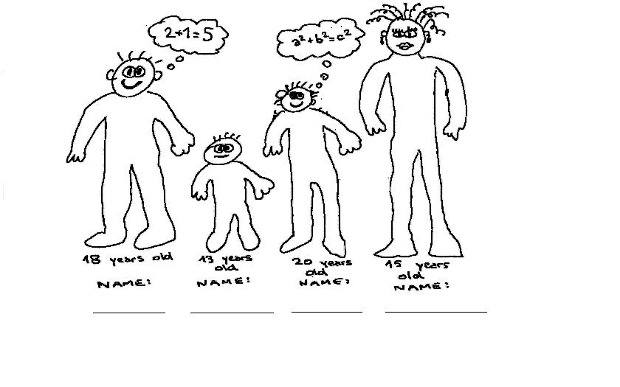

Where do these go?

Tall, happy, intelligent, pretty, old, interesting, beautiful, cute, big, young

+er | - y + ier | more

Special: Good – better; bad – worse.

Who is who?

Cindy is taller than Alice.

Jane is taller than Cindy.

Mary is older than Alice.

Jane is happier than Alice.

Cindy is more intelligent than Jane.

Mary is prettier than Cindy.

Cindy is older than Jane.
Survey

Write questions about famous people, ask your classmates and write their answers.

Question | Name & Answer | Names & Answer | Name & Answer | Names & Answer

Sample Lesson 2 – Comparatives 2

Name: _____________ Date: / / Teaching time: ______________

Action points – (These are the suggested techniques/ideas to try in your next practice teaching. See trainer’s observation notes from your last practice teaching session and copy the action points here)
1. Giving Ss lots of time to practice with each other.
2. Teach a small part and then add gradually to it.

1. What are you teaching?

- Language points – review comparative form from SL 1, confirm use of more/less & who/which, introduce Q-form: “Which/who is more/less ______, A or B?” and introduce how to express agreement and disagreement: I agree/I disagree.
- Language skills – speaking & grammar
- Cultural Aspects – comparing the qualities of two things – agreeing or disagree w/ opinion

2. What are your Student Learning Objectives for the lesson? (These should be specific and describe observable student behaviors, which you will be able to see in class.)

By the end of the lesson, SWBAT:

Show the ability to ask and answer each other’s Qs comparing two things or people (using: “Which/Who is ________, A or B?” and answering: “A/B is___” “I agree/I disagree.” by playing the game ‘Consent.’

3. When/How in the lesson will I check students’ progress toward the above Learning Objectives? What behaviors/activities will show me whether they have mastered the material?
Ss will play a game where they fill in the appropriate adjectives and people creatively as T monitors.

Preliminary considerations:
a. What do your students already know in relation to today’s lesson?
How to ask each other the Q: “Is A ____er/more/less than B?”

b. What aspects of the lesson do you anticipate your students might find challenging/difficult?
Finding errors in the form or meaning of example sentences at the beginning of the lesson.

c. How will you avoid and/or address these problem areas in your lesson?
Encourage Ss to discover the grammar and use their prior knowledge and classmates to learn—this will be a routine I set up for them.

Steps | Stages | Time: guess here | Procedure/Steps--these need to be written in the perspective of what the students do | Focus  S-S, T-S, etc. | Activity Purpose
1 |  | 10 | * T reviews the “Is A ____ than B? with objects, pictures or students in class.  * T teaches intros new stem to question: “Which/who is ____ interesting, A or B?” and elicits “more” or “less” from Ss.  * T reviews some sample sentences with errors for the Ss to identify with both people and things compared using the new question. | T-Ss  T-Ss/  Ss-T  T-Ss  Ss-T | Ss review grammar point and add new concept.  Ss access prior knowledge and inductive process is used to discover grammar.
2 |  | 5 | * T previews p. 130 “Structures 1” and checks Ss understanding of USE for less/more: T asks focusing Qs: How many sentences have missing words? Use guiding Qs: How much is the CD player? How much is the watch?  * T provides scaffolding on PPT or WB  * T models pair work by playing both parts of the dialogue in “Structures 1”. T models and does controlled group practice (T-Ss)  * T models the same dialogue with a S (using the watch/CD player to model MEANING/USE of less/more).  * T has two Ss model the same dialogue (using the pencils).  * T uses CCQs to check to see if Ss understand the task: Is this a speaking activity or a writing activity? DO you do this alone or together? Point: Who is your partner?  *Ss practice the dialogue with a partner. | T  T-Ss  T-S  S-S | Ss demonstrate FMU of TL  Ss apply the concept with limited possibilities for error but an increased challenge in pairs.
3 |  | 5 | Top of page 125 - “Look and Say II”  * Optional: Ss demonstrate USE for who/which by completing chart on WB  *T previews task by having Ss look at the pictures. T checks USE of who/which by asking Ss: When do we use who? When do we use which? In the first one will we use who/which? Why?  * T models (T-Ss & Ss-T)  * Ss practice the dialogue in pairs: A asks the question using the language provided and B answers the question.  Optional: For lower level Ss who need more guided practice  → Switch step 3 and 4. Do the bottom of page 125 first so Ss can practice who alone and then do top of page 125 so Ss can practice who/which together | T-Ss  S-S | S practice in a controlled setting.
4 |  | 5 | Optional (It only focuses on who)  Bottom of page 125 - “Work in Pairs”  * Ss use picture as prompt – Ss brainstorm adjectives and T writes on WB  * Ss use the Q: “Who is…” and the short answer: “A is….” to the new dialogue. | S-S | The textbook is adapted to fit Ss learning needs.
5 |  | 7 | * T elicits Korean places and movie stars and the possible adjectives to describe them (tall, short, thin, fat, rich, good, bad, intelligent, attractive, famous, talented, respected) make chart on WB:  * T scaffolds the dialog by putting the following on the WB:  A: “Which/ Who is _______, A or B?”  B: “A is _____.”  A: “I agree/ disagree”  * In pairs, Ss take turns asking each other Qs about famous Korean places and people.  NB: For lower level Ss having noun and adj. match in the chart above can be helpful when they do the less controlled practice | Ss-T  S-S | Ss prior knowledge is accessed.  Ss practice in a freer communicative way.  Scaffolding is provided to assure that Ss succeed  New language is introduced and practiced  Ss have opportunity to personalize their learning
  Korean places | adjectives | Famous Koreans | adjectives
6 |  | 10 | **Consent**  *Make sure all dialog support has been removed from WB and PPT. Lists of adjectives, names of famous people or places can stay on the WB  *Ss get into three groups of 5. Each S receives a slip of paper with five columns on it. (Ss name, 2 People/2 Things, Adjective, their answer and score)  * Ss fill in their slip of paper either putting in two people or two places/things. Ss also write an adjective (in base form) to compare these items. Ie. “Brad Pitt, 강호동, handsome.” They must also fill in the “Your answer” section according to their own answer.  * T guides Ss in filling out the game sheet. T can ask: What your name? Where will you write it? For the second column T can ask: What are you writing in the third column? How many people/things will you write down? For the third column T can ask: What kind of word goes here? What kind of words do we use to talk about people and things? Can you give me a word that tells me about a person or thing? For the fourth column T can ask: What will you write here? Are you writing what you think or what your classmates think? For the fifth column you can ask: How do you get a point?  * Ss make questions based on what they have written on their strips:  A: “Which is _____er A or B?” or “Who is better, A or B?”  B: “A is…...”  A: I agree/ disagree.  * Ss ask their partner. If their answers are the same, they must answer “I agree” and give themselves a point. If the answers are different, the student must answer “I disagree” and cannot get a point.  * Ss move into groups and ask their questions to each other.  * Ss change tables and ask each other another group’s questions.  * T monitors the game as Ss play listening for fluency. | S-S | Ss are checked on their mastery of the objective individually.  Ss personalize the material by asking e/o questions about classmates - generating interest.

PPT available for this lesson.

False Sentences

Fix these sentences:

- Brad Pitt is handsomer than Shrek.

- Angelina Jolie is more beautifuler than Princess Fiona.

- Julia Roberts is more smarter than Albert Einstein.

- Queen Elizabeth is more old than Jennifer Anniston.

- Soccer is more good than tennis.

Fix these sentences:

- Brad Pitt is handsomer than Shrek.

- Angelina Jolie is more beautifuler than Princess Fiona.

- Julia Roberts is more smarter than Albert Einstein.

- Queen Elizabeth is more old than Jennifer Anniston.

- Soccer is more good than tennis.
Consent Game Sheet

Your Name | 2 people | Describing Words | Your answer | score
Your Name | 2 things | Describing Words | Your answer | score
Your Name | 2 people | Describing Words | Your answer | score
Your Name | 2 things | Describing Words | Your answer | score
Your Name | 2 people | Describing Words | Your answer | score

Sample Lesson 3- “The Romance of a Busy Broker” – Pg. 126~128

Name: ________________________ Date: / / Teaching time: ____________________

Action points – (These are the suggested techniques/ideas to try in your next practice teaching. See trainer’s observation notes from your last practice teaching session and copy the action points here)
1.
2.

1. What are you teaching?
- Language points – broker, romance, rush, secretary, human being, machine,
- Additional Vocabulary: right away, to keep ringing, to get married, no longer
- Language skills – reading

2. What are your Student Learning Objectives for the lesson? (These should be specific and describe observable student behaviors, which you will be able to see in class.)

By the end of the lesson, SWBAT:

3. When/How in the lesson will I check students’ progress toward the above Learning Objectives? What behaviors/activities will show me whether they have mastered the material?
When Ss answer the specific comprehension check questions and express their opinions about what happened in the story and why

Preliminary considerations:
a. What do your students already know in relation to today’s lesson?
The meaning of some of the vocab (secretary, get married, machine).
b. What aspects of the lesson do you anticipate your students might find challenging/difficult?
Ss may struggle at first to come up with ideas for the post activity.

c. How will you avoid and/or address these problem areas in your lesson?
If Ss have problems doing the post activity I will try to elicit ideas from the Ss by asking guiding Qs..

Steps | Stages | Time: Guess here | Procedure/Steps--these need to be written in the perspective of what the students do | Focus  S-S, T-S, etc. | Activity Purpose
1 |  | 5 | *Greet Ss and ask if they like movies. Ask Ss what kind of movies they like, write on WB and try to elicit romance  * Pg. 126 Ss look at the picture (T asks focusing and guiding Qs: What do you see? How many people in the picture? Where do you think they are? What is his job? What is her job? and T shows title and Ss try to predict the story.  * T provides some guiding questions: Who do you think is having a romance? Who is the Broker? Do you man is happy? Do you think the woman is happy? | S-S  S-T | Prior knowledge is accessed.  Many skills are used in a lesson to help with comprehension of story.  Ss use prediction as a reading strategy.
2 |  | 8 | * Ss go over the FMU of vocab necessary to understand the text: broker, romance, rush, secretary, right away, human being, machine, to keep ringing, to get married, no longer.  *Ask Ss specific CCQs, e.g. “Is a broker like a businessman or a farmer?” “What’s another word for romance?” “Does a secretary work in a department store or an office?”  *Ss confirm their understanding by having Ss match words with definitions. Ss work collaboratively before T checks answers.  Optional: Ss do a collaborative discovery activity and help each other learn new vocab. | S-S | Ss get a chance to teach each other the vocabulary.
3 |  | 6 | *T writes/shows the following Q on board: “Is the story happy, sad or funny?”  What’s the man’s name? What’s the woman’s name?  *T tells Ss they have several minutes to find the answer.  *T asks: Do you read the whole text?  *Ss share answer with partner before sharing w/ the whole class.  *T has Ss raise hand to answer first Q  *T elicits/reviews key vocab words by asking follow-up Qs:  What does the man do? What does the woman do? | T-S  S  S-S  Ss-T | Ss are given a general reading task.  Peer checking and raising hands to create a safe and comfortable learning environment
4 |  | 6 | *T puts the following Qs on the board:  What does the man do all day at work?  When did Harvey take a break?  What is the relationship between the secretary and the broker?  *T tells Ss that they have 5 minutes to read and find the answers (Note: If Ss have trouble understanding the word “relationship,” T can guide them by asking: Are they brother and sister? Friends? Etc.)  *Ss share their answers with a partner before sharing with the whole class. (Optional: T asks Ss to show e/o where in the text they found the answer) | T-S  S  S-S  Ss-T | Ss are given a reading task that is more specific and Ss are given additional time to read.  Ss use the vocab in context of the story in a step by step process.
5 |  | 6 | Optional:  *T gives Ss sentence strips that summarize the story.  *Ss put strips into the correct sequence. | Ss-Ss | The sequencing activity provides an alternative way to assess Ss understanding of the specific details in the text  Also provided a activity that requires additional reading and prepares then for more the more difficult assessment Qs.
6 |  | 6 | * T puts the following Qs on the board:  Why was Miss Leslie surprised at the end of the story?  How do you think Harvey Maxwell felt at the end of the story?  Why did Harvey Maxwell forget he was married?  *Ss share answer with partner before sharing w/ the whole class.  Optional: Have Ss pass a stuffed animal to share their answers | T-S  S  S-S  Ss-T | Ss are given more difficult reading Qs – Ss demonstrate a comprehensive understanding of the text by using inference to answer the Qs – A kinesthetic component is added to increase Ss participation/autonomy
7 |  | 8 | * T puts the following on the board:  After work what happens?  Does Harvey say he’s sorry?  Is Miss Leslie angry?  Write two sentences about what happens next  Then draw a picture  *T confirms that Ss understand directions by asking:  What are you going to do first write or draw a picture?  How many sentences are you going to write?  Optional: Have Ss brainstorm ideas or make mind map on the WB before making the poster to support lower level Ss in the task. | S-S | Ss are again given an opportunity to personalize the text and to think creatively by going beyond the text.

Directions: Match the pictures, words, definitions and sentences to each other.


human being go quickly; hurry I use a washing _____ to wash my
clothes.
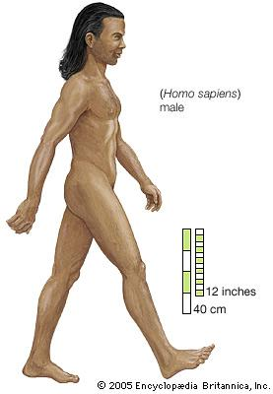

machine a person who works in an I am late for my 3:30 meeting.
office. I need to ____.



rush a person; man and/or She is my ____. She can copy
woman the paper for you.

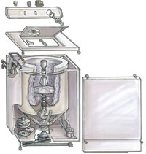

secretary engine; tool; device We are all _______. People
shouldn’t hate each other.

Vocabulary in Context for “The Busy Broker”

When I had some extra money, I went to a broker to help me to invest it and make more money.

Some people really love to watch movies about romance, I guess they love the feelings of seeing people in love.

It’s 3:30pm and our appointment is at 3pm! We need to rush!

Can you ask the secretary to help you type this document up?

I’m not going to wait until tomorrow. I’m going to do this right away.

We are all human beings so we need time to rest. We are not machines.

I heard the phone ringing but I couldn’t find the phone anywhere!

I used to be a student, but I’m no longer a student. Now I’m a teacher.

When the door opened all the people poured into the store. They all wanted to get the best prices.

Vocabulary Definitions for “The Busy Broker”

Broker—someone who sells stock (share of a company) for example on the Kospi or Nasdaq
Romance—the loving feelings that 2 people have toward each other
Rush—when you need to hurry, move quickly
Secretary—someone who works in an office (maybe typing, filing, answering the phone)
Right away—not waiting even a minute, immediately
Human being—another word for “person”
Machine—something that is automated or does a certain job so that people don’t have to do it on their own
To ring—the sound or act a phone or a doorbell makes
No longer—it used to be a certain way but now it’s not that way anymore
To pour into—when lots of people come quickly into a place like water would fill a cup
Sample Lesson 4—Speaking and Grammar – “Describing Experiences”

Name: _____________________________ Date: / / Teaching time: ___________________

Action points – (These are the suggested techniques/ideas to try in your next practice teaching. See trainer’s observation notes from your last practice teaching session and copy the action points here)
1.
2.

- What are you teaching?
- Language points – prepositions related to advertisements (from an ad on TV, from an ad in a newspaper, from a friend, etc), adjectives (delicious, great, fun, boring), and places
- Language skills – speaking and grammar
- Cultural Aspects –being able to maintain a conversation in English

2. What are your Student Learning Objectives for the lesson? (These should be specific and describe observable student behaviors, which you will be able to see in class.)
By the end of the lesson, SWBAT:

3. When/How in the lesson will I check students’ progress toward the above Learning Objectives? What behaviors/activities will show me whether they have mastered the material?
When Ss are interacting with each other using the dialogue and its elements they have practiced until eventually they don’t need the support language written on the board.

Preliminary considerations:
a. What do your students already know in relation to today’s lesson?
Ss can brainstorm places where they’ve been, adjectives, and how they usually find out about things.
b. What aspects of the lesson do you anticipate your students might find challenging/difficult?
Feeling confident with the conversation.
Remembering which prepositions go with the different forms of media (i.e. in the newspaper, on TV, on the radio, etc).
c. How will you avoid and/or address these problem areas in your lesson?
By giving the Ss a lot of chances to practice the dialogue and slowly erasing it.
By giving the Ss strategies to remember which preposition goes with each form of media and writing it on the board.
Steps | Stages | Time -guess here | Procedure/Steps--these need to be written in the perspective of what the students do | Focus  S-S, T-S, etc. | Activity Purpose
1 |  | 3 | *Pre-teach vocab (recommend, magazine, delicious, ad) eliciting the meaning from Ss if possible.  * Ss identify foods in the pictures on pg. 141. | Ss-T  T  Ss-T | - Activate Ss’ schema.  - Set Ss up to succeed at listening.  - Using visuals helps some learners.
2 |  | 2 | * Ss read the 2 Qs on pg. 141.  * Ss listen and answer the Qs.  * Ss check their answers with a partner before they check as a class. | S  S  S-S, Ss-T | - Authentic TL input  - Ss have a reason to listen.  - Ss share answers with a partner so promote risk taking and peer learning.
3 |  | 2 | *T asks several Ss: What do you like?  *T writes on board: A: What do you like? B: I like _________.  *T gets Ss to ask T – (Ss and T practice in controlled way)  *Ss discuss the question with 2 other Ss:  A: What do you like?  B: I like _________. | T-S  Ss-T  S-S | - Review/recycle previous language point  - To make Ss active in all stages of the lesson.  - Ss personalize the TL they know and see how today’s lesson is relevant.  - To increase Ss motivation and to activate Ss schema.
4 |  | 3 | *T writes on board: How was ____________? It was _______.  * T models the stress, intonation and structure.  * Ss practice and work on stress, intonation and structure. | T-Ss  T-Ss  S | Practice with a small unit of language (Chunking).  Practice pronunciation within a lesson.
5 |  | 4 | Pg. 142 - “Look and Say I”  *Ss use eye contact (read and look up) and change partners to practice again. | S-S | Apply what they’ve learned to a new context—Ss are active.
6 |  | 6 | * Ss do “Work in Pairs” dialogue but use the dialogue T writes on board:  A: I went to a Japanese restaurant last Sunday.  B: A Japanese restaurant? How was it? (the understanding response is added)  A: The food was good.  B: Great. (optional “I want to go there…”)  T starts by playing both parts, then ½ class is one part and T is the other, switch, then ½ class is one part and ½ class is the other, then Ss do dialogue in pairs.  T slowly erases the dialogue as Ss memorize it. | S-S  T-Ss, Ss-T  Ss-Ss, S-S  S | Apply to a conversation with peers—develops comfort and respect among learners.  Ss get comfortable with rhythm and content of conversation.
7 |  | 4 | ** Ss do “Work in Pairs” on p. 142  *Ss brainstorm authentic places to go (movies, friend’s house, etc) and adjectives (fun, great, boring) and time (last year, last weekend)  *T makes chart and writes suggestions on board | S-S  Ss-T | Access Ss’ prior knowledge.  Giving Ss a way to interact at all stages of the lesson.
  Where | Adjective | When
  Beach | Rainy | Last summer
8 |  | 6 | *T puts gapped dialog on PPT and ask Ss to practice the dialog by filling in the gaps with info in chart on WB  *T models parts A & B: A: I went to the beach last weekend.  B: How was it?  A: It was very hot.  B: I want to go there some time.  *T models dialog: T- Ss // Ss - T.  *Ss practice the gapped dialogue with a partner using eye contact (NO reading) three times using new words from the board each time.  *S switch roles and practice again  Optional: If Ss want to add additional places to their dialog →Ss are encouraged to ask T for words that they don’t know in English (Put help language on WB: “How do you say _______ in English?”). | T-Ss  T-S  S-S  Ss-T | Ss practice several times with all target language in a natural manner. Personalize and expansion of vocab.  T corrects errors as related to target language to work on accuracy.  Ss can stay in English because they have help language on board.
9 |  | 4 | * T elicits how Ss know about places to go and lists them on the board (Look and Say II without opening book).  *T starts them off with an example (ie: From an ad on the internet/on TV/in a newspaper/in a magazine/on the radio, from a friend)  * T puts Ss examples into columns on to WB according to prepositions as Ss call them out.  * T adds/elicits prepositions and asks/gives Ss the strategies that usually printed/hard copy material uses “in” mechanical options use “on” people use “from”. | Ss-T  T-Ss  Ss-T  Ss-T | Access Ss’ prior knowledge.  Intro prepositions and strategies to Ss—including other skills than listening and speaking.  Ss get strategies on how to categorize prepositions.
  ? Ss → from | ? Ss → in | ? Ss → on
  friend  mother | newspaper | internet  TV
10 |  | 2 | * Ss do dialogue using 3 places and ways they heard about them in pairs:  “How did you know about the restaurant/store/sale?” “From an ad in the newspaper” (Look and Say II pg 143). | S-S | Ss practice several times with all the target language in a natural manner.
11 |  | 4 | *T elicits new places from Ss and writes them on the board.  *Ss repeat dialogue choosing 3 different places and add the following information:  B: How did you know about _______?  A: From ________. | S-S | Adding a challenge as Ss develop comfort.  Personalizing the material.
Complete Dialog to be used in the Fluency:

A: I went to (where) _____(when)______.
B: How was it?
A: It was .
B: How did you know/hear/learn about _______?
A: I heard/learned about from ________ / from an ad in _______ / from an ad on _______.
B: Sounds great. I want to go there some time. / That doesn’t sound_____. I don’t want to go there.
Sample Lesson 5 – Inventions Make Our World Smaller (from New Parade pp. 154~174)

Name: ___ Date: _____ ____ Teaching time: _(45 min)______
Action points – (These are the suggested techniques/ideas to try in your next practice teaching. See trainer’s observation notes from your last practice teaching session and copy the action points here)
1.
2.
1. What are you teaching?

Language points – 1st (wonder, discover, invention, firework, protect, enemy)
- 2nd (inventors, a number of, riddle, experiment, kites, flew, continue)
- 3rd (calendar, celebration, imagine)
- 4th (Aztecs, emperor, present, explorer, exports)
- Language skills – Reading
- Cultural Aspects – To persuade others into their opinion in debate and to share their information in a collaborative group.

2. What are your Student Learning Objectives for the lesson? (These should be specific and describe observable student behaviors, which you will be able to see in class.)

By the end of the lesson, SWBAT:

Optional Post Activity: persuade others that their invention is more important than others by giving specific examples in debate.

3. When/How in the lesson will I check students’ progress toward the above Learning Objectives? What behaviors/activities will show me whether they have mastered the material?
- When Ss answer the specific comprehension check questions, fill out the graphic organizer about the story.
- When Ss persuade others to choose their invention by giving specific examples in debate.

Preliminary considerations:
a. What do your students already know in relation to today’s lesson?
- Most students will be familiar with the inventions (fireworks, chocolate, airplane and calendar) and countries (China, Mexico, Egypt, America)
b. What aspects of the lesson do you anticipate your students might find challenging/difficult?
-Ss might be confused about making a jigsaw group and struggle when they are asked to share their information.
-Ss might avoid presenting their opinions and persuading others in debate.
c. How will you avoid and/or address these problem areas in your lesson?
- I will give Ss number (1,2,3) and make a new groups, then I will show their new seat visually on PPT, and check it through CCQs.
-I will encourage Ss to present their opinion by giving Ss much time to prepare their opinions, using extrinsic motivations (verbal praise) intrinsic motivation(stickers, candies) and making comfortable atmosphere before starting the debate.
Steps | Stages | Time (min): Guess here | Procedure/Steps--these need to be written in the perspective of what the students do | Focus  S-S, T-S, etc. | Activity Purpose
1 | P | 3 | Greetings   introduce my name, small talks  Eliciting  1. T acts an inventor and introduces funny inventions.  2. Ss look at the picture on PPT (inventors, fireworks, calendars…)  -T asks focusing/guiding Qs ; What is this? Who is he?  -T elicit the word invention/inventor from Ss by using picture.  3. T shows the title of the text ‘Inventions make our world smaller’  -T elicits inventions that Ss’ think that make our world smaller. | T-Ss  T-Ss  Ss-T | ▪ Build rapport.   Ss’ prior knowledge is assessed.   Ss use prediction as a reading strategy.
2 | P | 7 | Pre-teach Vocabulary  *Ss go over the FMU of vocabulary necessary to understand the text.  1. Give Ss worksheet of picture dictionary.  2. Ss fill out the picture dictionary in a group.  (Ss work collaboratively before T checks answers.)  3. When most of Ss don’t know specific words, T provides more clues using picture, example sentences, modeling… etc.  4. Ask Ss specific CCQs to confirm their understanding. | Ss-Ss  T-Ss  Ss-T | ▪ Validate Ss participation and build confidence in the topic.   Activate Ss background knowledge.   Access Ss’ prior knowledge and inductive process is used to learn a new vocabulary/expressions.
3 | D | 5 | Jigsaw Reading 1  1. Ss are split into 3 groups.  2. Ss read text and answer the general Qs.  -One group reads part 1&2 (fireworks, airplanes)  -Another group reads part 1&3 (fireworks, calendars)  - The other group reads part 1&4 (fireworks, chocolate)  3. Ss read text again and answer the more specific Qs  (Ss can be encouraged to take notes and check their understanding)  * Ss reminded that they will have to tell the others what they read so that Ss have a reason to read.  4. Ss check and share their answer in a group.  *Ss are encouraged to use the TL  5. T monitors each group’s pace and achievement. | T-Ss  Ss-Ss  T-Ss | ▪ Ss are given reading tasks from general to specific.   Ss are able to learn the reading strategy.   Peer checking to create safe and comfortable atmosphere.

4 | D | 7-10 | Jigsaw Reading 2 (retell the story/ information gap activity)  1. Ss are regrouped.  – Ss who read part 1 pair with Ss who read part 2 and part 3  2. Ss exchange their information about 3 different texts.  -Ss make a summary of the text by using graphic organizer.  - T monitors each group.  Check Ss’ comprehension  3. O/X quiz for check Ss’ general understanding of the text.  4. Parcel game for check Ss’ specific comprehension of the text. | T-Ss  S-S  (T-S)  Ss-Ss | ▪ Ss have chance of cooperative learning by jigsaw reading.   Ss are given tasks that are from general to specific.   Ss demonstrate their understanding of the text by summarizing the story using mid-mapping.   Kinesthetic component is added to make comfortable environment.
5 | D/P | 7 | Debate (*optional)  1.T puts the following Qs on the board;  “Which invention do you think is most important?”  2. Each group chooses one inventions from the text.  3. Each group discusses and writes 3 or more reasons about their opinion.  4. Debate- Ss prove their opinion giving specific examples.  5. Ss choose the best invention. | T-Ss  Ss-Ss | ▪ Debate activity provides an alternative way to assess Ss’ understanding of the specific details in the text.   Using inference to accomplish their tasks.   Ss are given an opportunity to personalize and to think creatively.   Ss are given a chance to write and speak their opinion about the text.(reading and speaking/writing skills are integrated)
6 | P | 5 | Personalization (Make your own inventions!)  1. T shows interesting inventions on PPT  2. Ss brainstorm ideas about making their own inventions.  3. Ss draw a picture and explain about their inventions.  4. Hang Ss’ own inventions on the wall and choose best item.  (*4. optional) | T-Ss  Ss-Ss | ▪ Ss personalize the text and think creatively by going beyond the text.

READING A
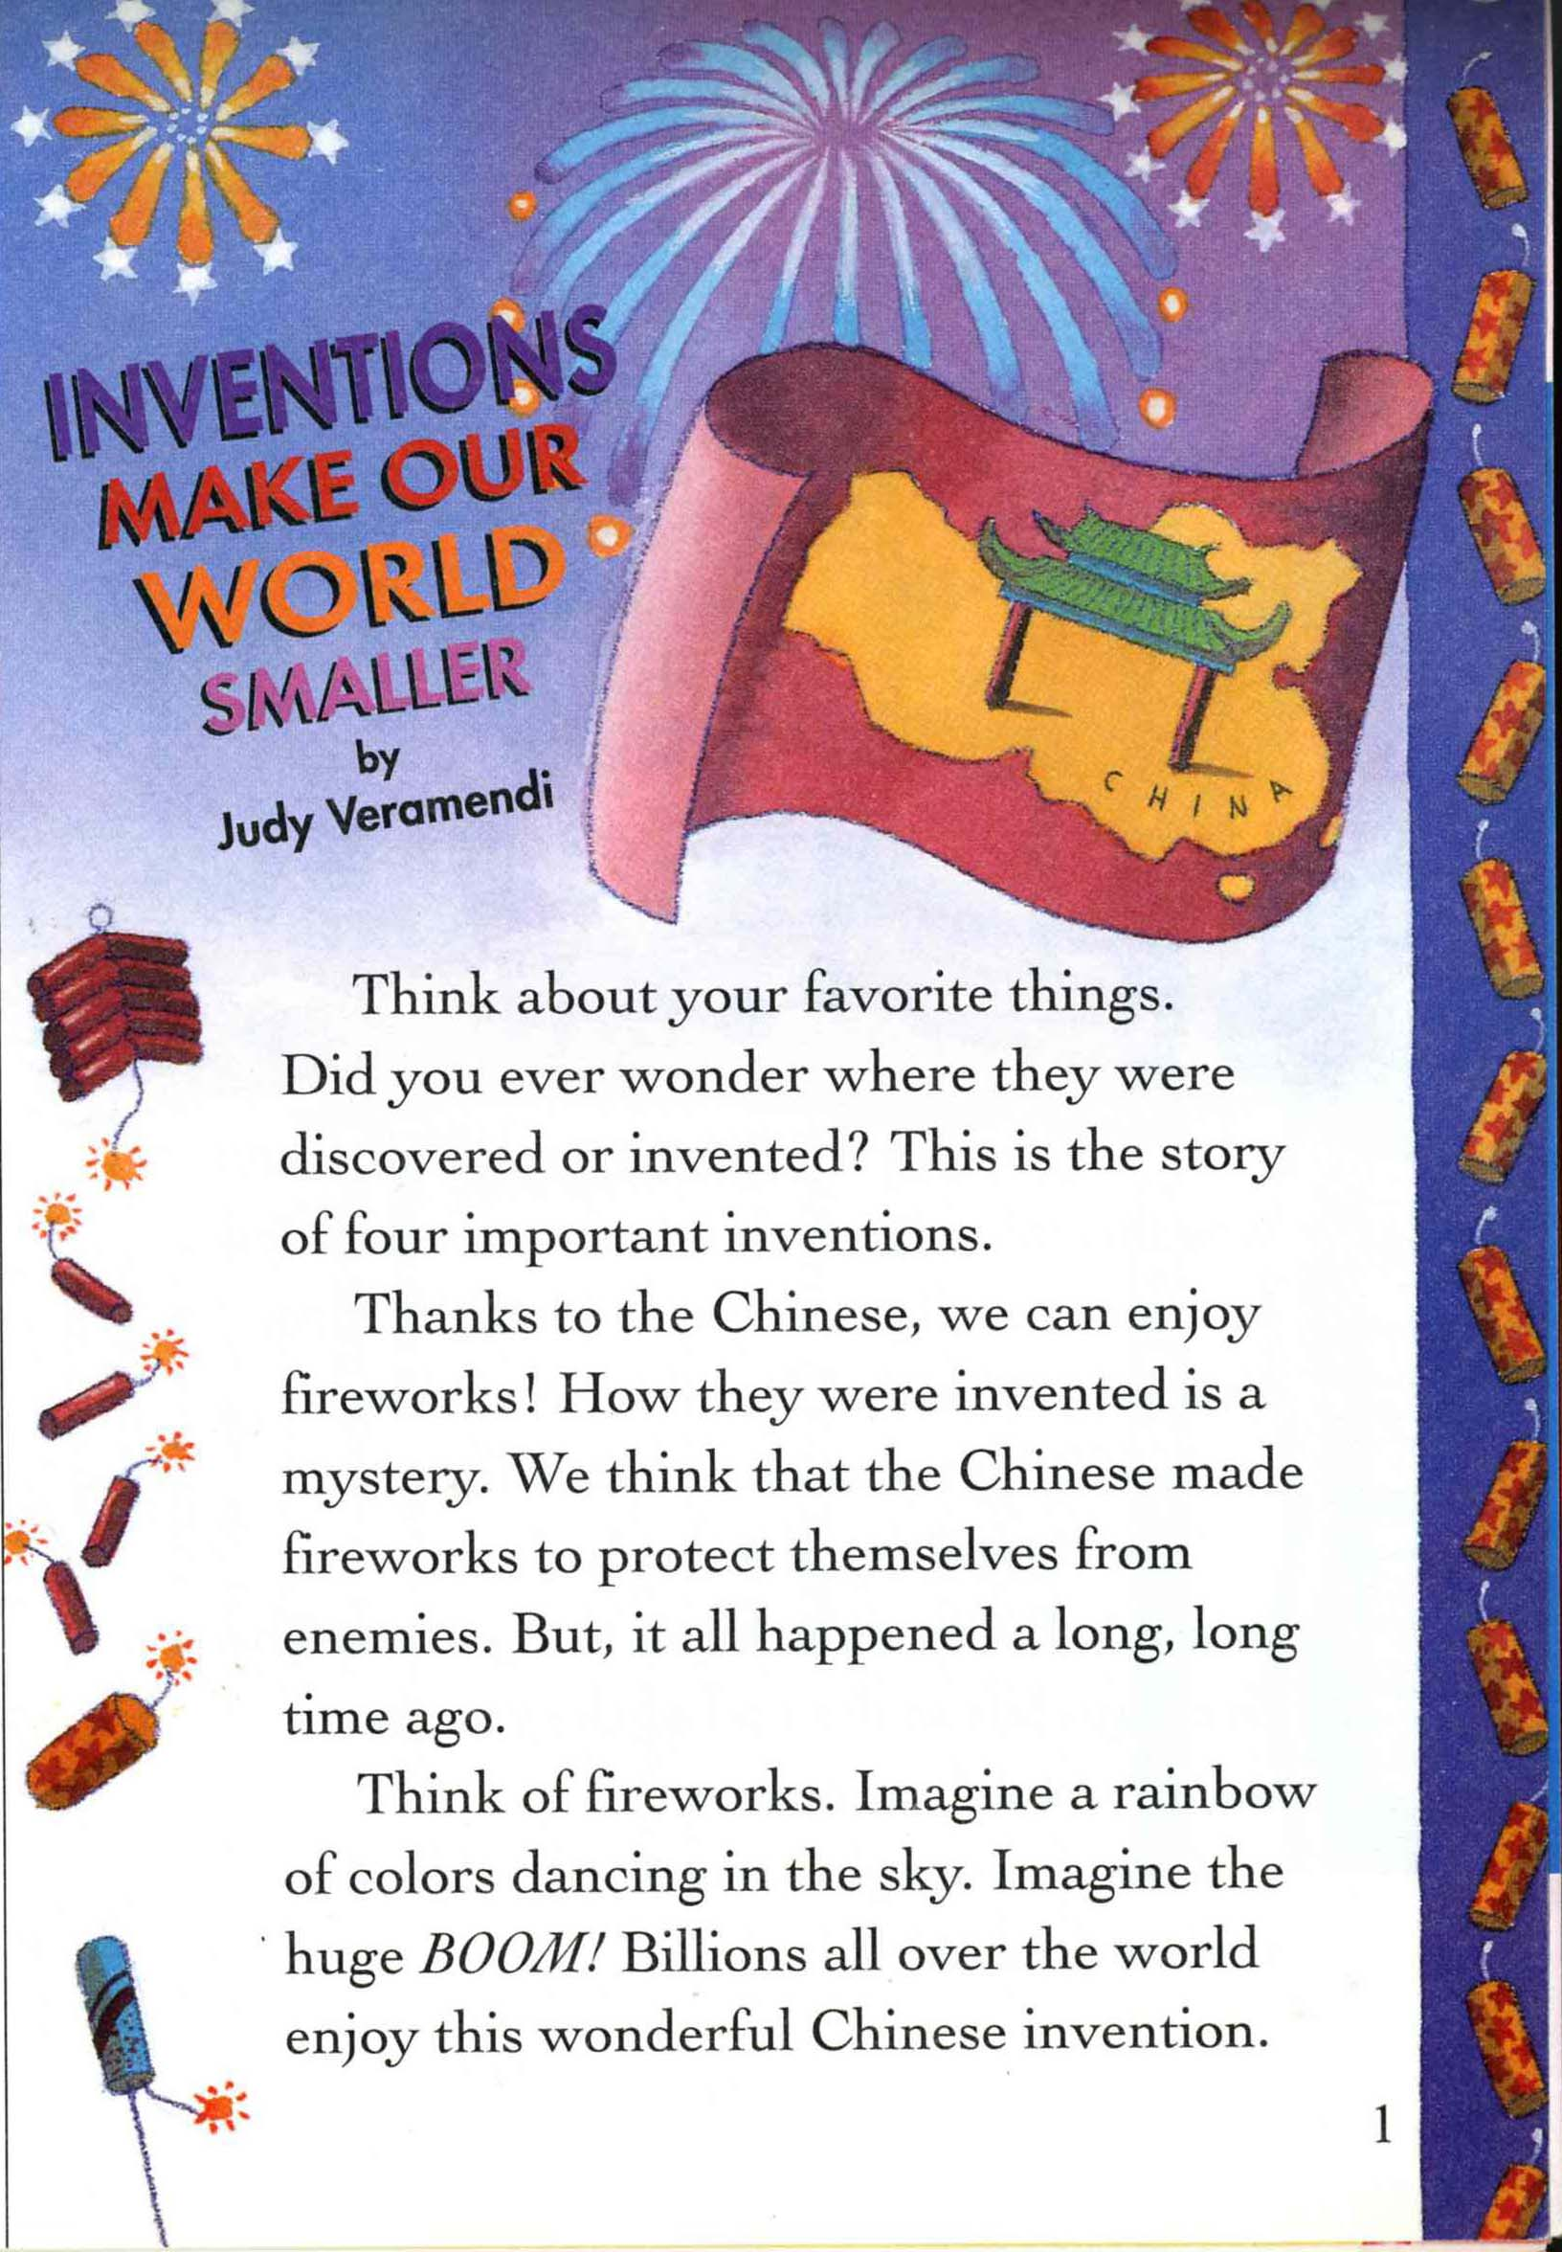 | 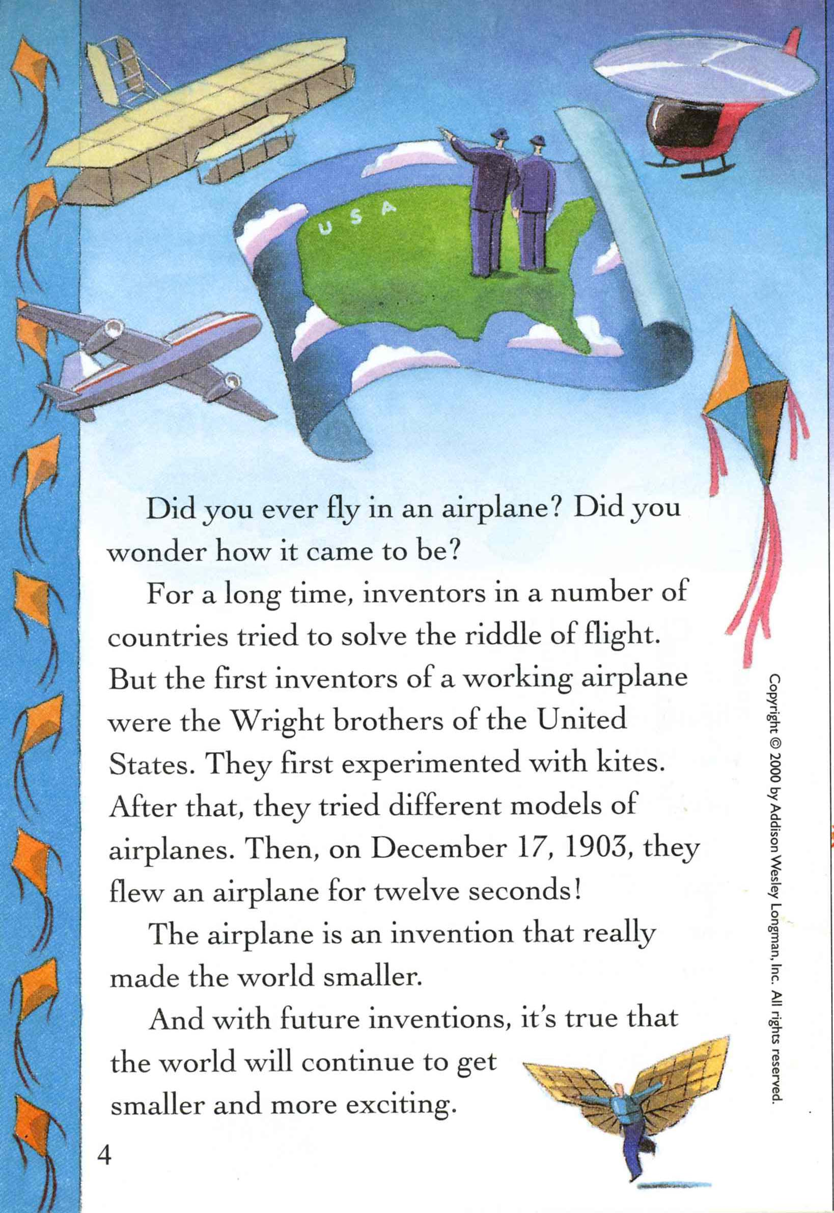
READING B
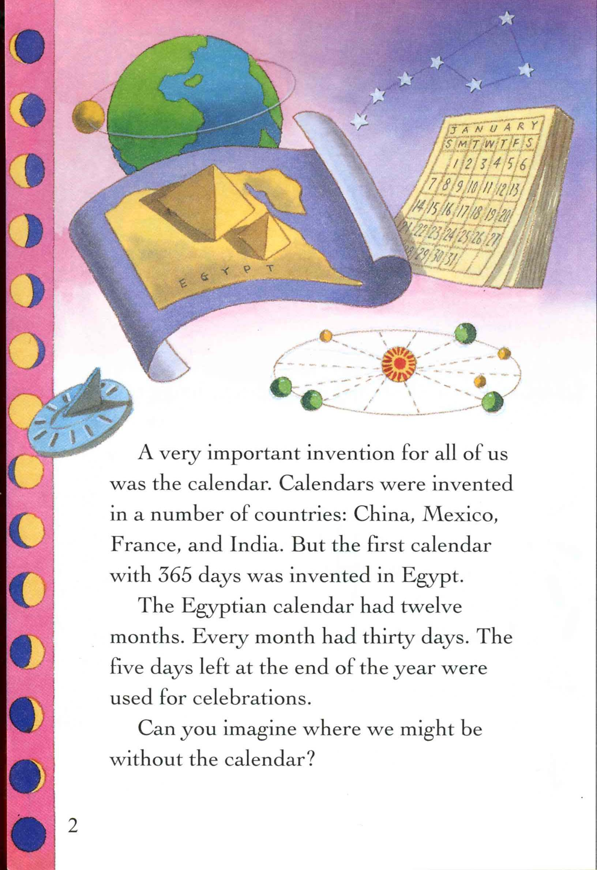
READING C
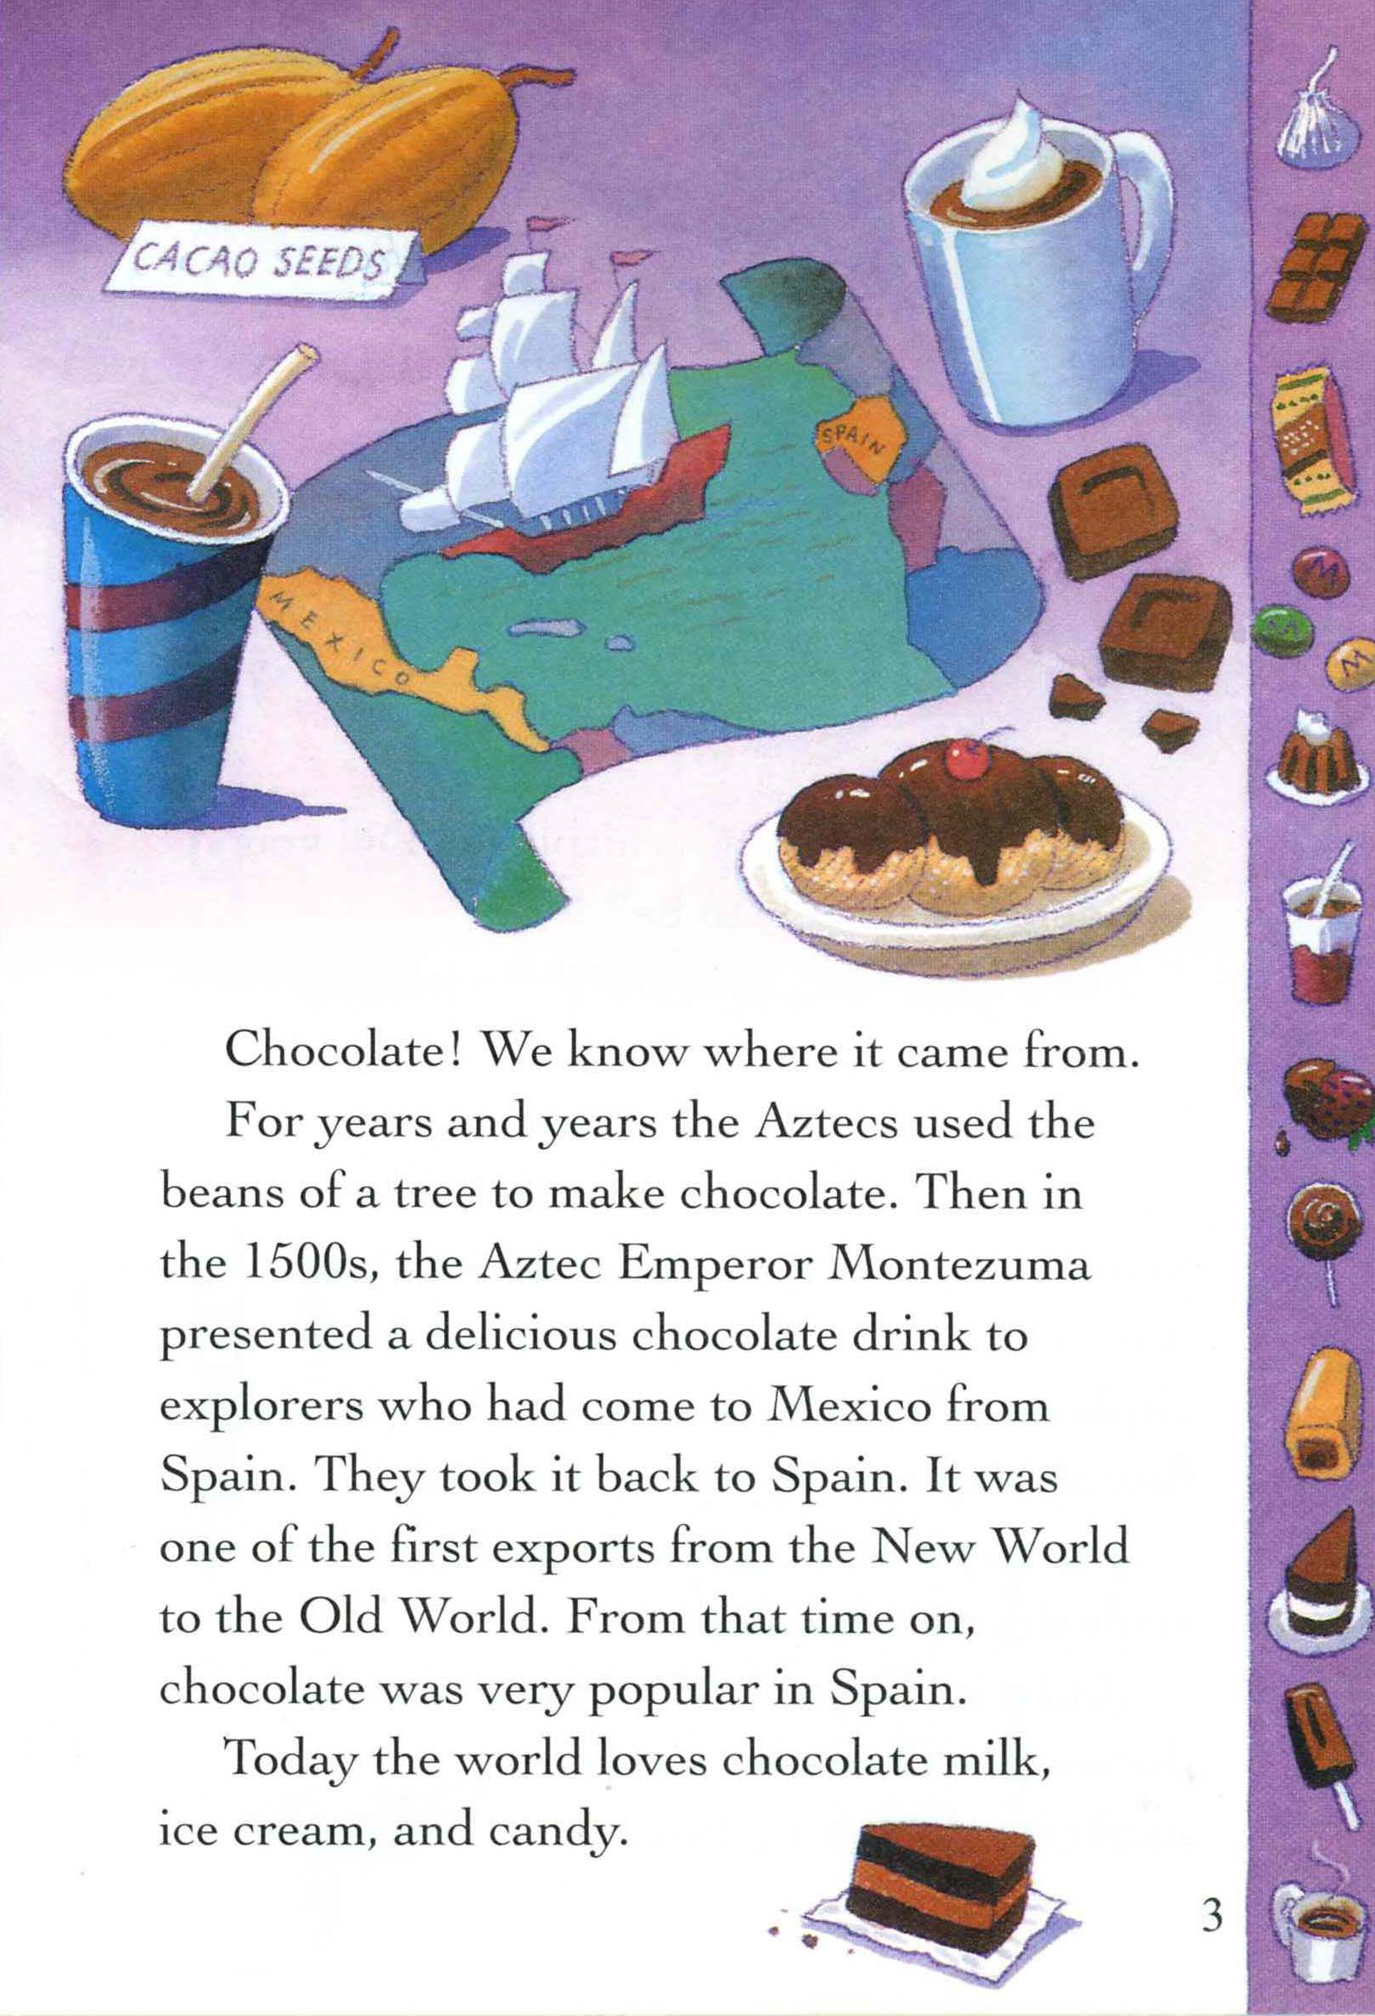

Picture Dictionary -Answer

 |  | 
Invent | Protect | Enemy | billion
Edison invented many things. | Let’s protect the environment. | The enemy tried to kill me! | 1,000,000,000
Riddle | Experiment | Flew | Celebration
= puzzle, quiz, mystery | I don’t like animal experiment. | Fly - Flew - Flown | Celebrate my birthday.
 | 
Aztecs | Explorer | Export | Bean
A group of Mexican Indian peoples | A person who travels strange places. | To send goods to another country | Coffee bean  Green bean

Picture Dictionary - Worksheet

Invent | Protect | Enemy | billion
Edison invented many things. | Let’s protect the environment. | The enemy tried to kill me! | 1,000,000,000
Riddle | Experiment | Flew | Celebration
= puzzle, quiz, mystery | I don’t like animal experiment. | Fly - Flew - Flown | Celebrate my birthday.
Aztecs | Explorer | Export | Bean
A group of Mexican Indian peoples | A person who travels strange places. | To send goods to another country | Coffee bean  Green bean

Graphic Organizer

Inventions
make our world smaller
Fireworks
Chocolate
Airplanes
Calendars
Where? China
Who? Chinese
When? A long time ago
How? It’s a mystery
Why? To protect themselves from war
Where?
Experiment with ______________
Who?
The first model flew for ______ seconds!
Egyptian Calendars
_______ months in a year
_______ days in a month
5 days for c____________
________ were used to make chocolate
The king gave chocolate to __________
Where: from M_________ to S____________

<Fireworks>
Group A

1. How did the Chinese make fireworks?

2. Why do you think the Chinese made firework?
(a. to protect themselves from enemies / b. to cook for dinner)

<Airplanes>

1. How long was the first airplane flight?
① 12 seconds ②17 seconds ③ 20 seconds ④ 12 hours

2. What did the first inventors use for experiment?
① fireworks ②birds ③riddle ④kites

Group A

<Fireworks>

1. How did the Chinese make fireworks?

2. Why do you think the Chinese made firework?
(a. to protect themselves from enemies / b. to cook for dinner)

<Airplanes>

1. How long was the first airplane flight?
① 12 seconds ②17 seconds ③ 20 seconds ④ 12 hours

2. What did the first inventors use for experiment?
①fireworks ②birds ③riddle ④kites

Group B
<Fireworks>

1. How did the Chinese make fireworks?

2. Why do you think the Chinese made firework?
(a. to protect themselves from enemies / b. to cook for dinner)

<Calendars>
1. How many days did the Egyptian calendar have in a month?
① 28 ② 29 ③ 30 ④31

2. How many days were left at the end of the year?
①2 days ② 3 days ③ 4 days ④ 5 days

3. How did the Egyptians use the last days?
① to work ② to pray ③ to celebrate ④ to take a rest

Group B

<Fireworks>

1. How did the Chinese make fireworks?

2. Why do you think the Chinese made firework?
(a. to protect themselves from enemies / b. to cook for dinner)

<Calendars>
1. How many days did the Egyptian calendar have in a month?
① 28 ② 29 ③ 30 ④31

2. How many days were left at the end of the year?
①2 days ② 3 days ③ 4 days ④ 5 days

3. How did the Egyptians use the last days?
① to work ② to pray ③ to celebrate ④ to take a rest

Group C
<Fireworks>
1. How did the Chinese make fireworks?

2. Why do you think the Chinese made firework?
(a. to protect themselves from enemies / b. to cook for dinner)

<Chocolates>
1. To whom did the Aztec king present a chocolate drink?
①explorers ② Chinese ③ inventors ④ Egyptians

2. What was the first export from the new world to the old world?
①chocolate ②ice cream ③candy ④ milk

3. Where did the explorers come from?
① Mexico ② Spain ③ China ④ Egypt

Group C

<Fireworks>
1. How did the Chinese make fireworks?

2. Why do you think the Chinese made firework?
(a. to protect themselves from enemies / b. to cook for dinner)

<Chocolates>
1. To whom did the Aztec king present a chocolate drink?
①explorers ② Chinese ③ inventors ④ Egyptians

2. What was the first export from the new world to the old world?
①chocolate ②ice cream ③candy ④ milk

3. Where did the explorers come from?
① Mexico ② Spain ③ China ④ Egypt

Pass the Parcel Game Questions

1. Why do you think the Chinese made firework?
(a. to protect themselves from enemies
b. to cook for dinner)

2. What did the first inventors use for experiment?
① fireworks ②birds
③riddle ④kites

3. How many days did the Egyptian calendar have in a month?
① 28 ② 29 ③ 30 ④31

4. How did the Egyptians use the last days?
① to work ② to pray
③ to celebrate ④ to take a rest

5. What was the first export from the new world to the old world?
①chocolate ②ice cream
③candy ④ milk

10. Where did the explorers come from?
① Mexico ② Spain
③ China ④ Egypt

1. Why do you think the Chinese made firework?
(a. to protect themselves from enemies
b. to cook for dinner)

2. What did the first inventors use for experiment?
① fireworks ②birds
③riddle ④kites

3. How many days did the Egyptian calendar have in a month?
① 28 ② 29 ③ 30 ④31

4. How did the Egyptians use the last days?
① to work ② to pray
③ to celebrate ④ to take a rest

5. What was the first export from the new world to the old world?
①chocolate ②ice cream
③candy ④ milk

10. Where did the explorers come from?
① Mexico ② Spain
③ China ④ Egypt

Sample lesson plan 6- Speaking – "Asking for and Giving Direction"

Name: __________________ Date: _______________ Teaching time: _______________

Action points –
1.
2.

1. What are you teaching?
• Language points – asking for and giving direction
• Language skills – speaking
• Cultural aspects - speech etiquette in asking for and giving direction

2. What are your Student Learning Objectives for the lesson?

3. When/How in the lesson will I check students’ progress toward the above Learning Objectives? What behaviors/activities will show me whether they have mastered the material?
When Ss are making their own dialogue with friends in "Info Gap" activity like this: "Could you show me the way to ?" "OK. Go straight 2 blocks and turn left at the corner……"

4. Preliminary considerations:
a. What do your students already know in relation to today’s lesson?
Ss know the meaning of the basic expressions: “Go straight." "Turn left." etc.
b. What aspects of the lesson do you anticipate your students might find challenging/difficult?
• Ss may feel uncomfortable when asked to talk with peers in group works.
• Ss may have troubles making a conversation to asks and give direction.

c. How will you avoid and/or address these problem areas in your lesson?
• I will keep Ss involved in the activities by arousing their competitive spirits.
• I will try enough modeling and practices before having Ss do pair/group works.
• I will get Ss to repeat the same necessary expressions in different activities.
• I will give Ss to learn from each other through group works.

Steps | Stages | Time | Procedure/ Steps | Focus  S-S, T-S, etc. | Activity Purpose
1 |  | 2 | "I AM A BLIND. HELP ME!"  •T acts a blind and asks Ss for help.  •Ss help T to find the way using the expression: "Go straight." “Turn left/right."  Greetings  •Personal Qs. | T-Ss/Ss-T | Makes Ss interested and involved.  Ss encounter SLO.  Elicit Ss' prior knowledge.
2 |  | 5 | Eliciting: "What did you hear?"  •T asks: “How did you help me? What did you say?” T writes expressions on the WB.  Presenting Key Expressions  •T gets Ss to learn the key expressions through PPT presentation.  Game: "SIMON SAYS"  •T does "Simon Says" game in which T gives instructions including key expressions.  •Ss practice the expressions in a controlled way. T supports Ss by providing TL. | Ss-T  T-Ss | Elicits key expressions from Ss. Reminds Ss of what they know. Provides opportunities for peer learning. Ss practice key expressions in a controlled way. Ss get interested.
3 |  | 5 | Presenting Extended Key Expressions  •T presents a map on PPT screen.  •T makes 4 dialogues of asking for and giving direction with Ss, introduces extended key expressions, and illustrates the meaning with the map on the map:  - Excuse me. Where is Star Bank?  - Go straight for two blocks.  - It's on your left/right.  - Turn left/right.  - It is next to E-mart.  - It is across from Hana hotel.  - Sorry, I'm a stranger here.  •T shows the expressions and gets Ss to read after him. | T-Ss  Ss-T  T-Ss | Makes Ss discover the extended SLO.
4 |  | 7 | Game: "Complete Dialogues of Giving Direction"  •T makes 3 groups for 4.  •T shows Ss a dialogue having a blank.  •Among 7 choices, Ss find the sentence appropriate to fill in the blank.  •Ss compete as a group. | Ss | Assess Ss understanding.  Encourage cooperative learning.  Make Ss involved in a less controlled activity.
5 |  | 9 | Practicing: Role Playing  - T shows the map with the same buildings in different locations.  - T models how to ask and give directions with a S.  - T puts Ss in pairs and asks them to practice the buildings in order. Both Ss should get a chance to ask and answer. | T-Ss  S-Ss  Ss-Ss  S-S | Does modeling and makes Ss Practice in a less controlled way.
6 |  | 8 | Info Gap: "FIND THE TREASURE!"  • T hands out maps to each pair.  (T prepares an A map and a B map)  • Ss take turns giving directions until all buildings on the map are identified except for the building with the treasure.  • Ss write the directions to the treasure on a piece of paper  • Ss check with other groups to see if they have the same answers  • T checks answers with whole group | Ss | Makes sure that Ss successfully acquire the SLO.  Makes Ss involved.

~ PPT Available
Map for info gap needs to be created, but maps on 7-25 and 7-26 can be adapted for the activity
Sample Lesson 7 – Grammar and Pronunciation – “Relative Clauses”

Name: _____________________________ Date: / / Teaching time: ____________________

Action points – (These are the suggested techniques/ideas to try in your next practice teaching. See trainer’s observation notes from your last practice teaching session and copy the action points here).
1.
2.

1. What are you teaching?
- Language points – relative clauses, word stress and sounds /ou/ and /f/
- Language skills – grammar and pronunciation
- Cultural Aspects --

2. What are your Student Learning Objectives for the lesson? (These should be specific and describe observable student behaviors, which you will be able to see in class.)

By the end of the lesson, SWBAT:

3. When/How in the lesson will I check students’ progress toward the above Learning Objectives? What behaviors/activities will show me whether they have mastered the material?
When the Ss are able to form their own complex sentences using relative clauses.
When Ss are able to identify the sounds and stress independently of the T.

Preliminary considerations:
a. What do your students already know in relation to today’s lesson?
Ss might be able to identify relative pronouns and make some guesses as to what the rules are.
b. What aspects of the lesson do you anticipate your students might find challenging/difficult?
Ss may struggle with making up their own sentences to combine.
c. How will you avoid and/or address these problem areas in your lesson?
I will guide the Ss to think of sentences that have the same subject and include additional information about that subject so they succeed.

Steps | Stages | Time- guess here | Procedure/Steps--these need to be written in the perspective of what the students do | Focus  S-S, T-S, etc. | Activity Purpose
1 |  | 6 | Pronunciation section: word stress  *Ss listen to stress on words and see stress marks Pg. 148 - “Sounds” Part A.  *Ss clap the stress pattern and repeat the words after the T.  *Ss raise their hands if the stress is on the first, second or third syllable when the word is said by T.  *Ss mark the stress on words on board and say the words to e/o. | S  T-Ss/Ss-T  Ss-T  S-S | Ss are given a chance to show that they recognize the differences in the sounds they are hearing.  Kinesthetic and Tactile learning styles are accommodated  Ss are given a chance to practice what they understand about the stress by marking.
2 |  | 8 | *Ss look at sentences with and without error and to try and find relative pronoun problems.  i.e.: I know a man who has a cat.  I see a cat which is black and white.  * T confirms Ss answers in large group and applies FMU and asks CCQs:  Why do we use ‘who’ here? Why do we use’ which’ here? Why do we use ‘who’ /’ which’; why not just use two sentences?  * T points out which relative pronoun is used for people/things  Optional: Ss do a collaborative discovery activity where Ss are given sample sentences, pictures and a graphic organizer to helps Ss inductively discover the rule for using who/which | S-S  T-Ss  T-Ss | Ss prior knowledge is accessed interactively--inductive methods are used.  S to S interaction in the presentation phase of an idea.
3 |  | 8 | *Ss practice combining two sentences that the T provides using the appropriate relative pronoun and using correct deletion in pairs.  (Ex: This is a book. Tom recommended this book.  This is the book which Tom recommended.)  This can be done on slips of paper as a kind of matching activity, as a tactile fold and tear activity or on one sheet of paper as a standard sentence combination drill.  Optional: T prepares human sentence cards and Ss practice combining sentences to form sentences with relative clauses.  *Ss practice filling in the blanks pg. 147 - “Structures” Part I.  *Ss check their answer with a partner.  *T confirms Ss answers in large group.  *T goes over what the two sentences could have been before they were combined.  (Ex: This is the story which Tom wrote.  Could have been: Look at this story. Tom wrote this story.) | S-S  S  S-S  Ss-T  T-S | Ss apply what they are learning in sequenced steps—using the textbook where appropriate to the learning and getting feedback on accuracy.  Ss work on form and use of structure.  The practice is controlled.
4 |  | 8 | *T models combining 2 sentences  *Ss get 6 sentences on strips and have to combine them with a relative pronoun to make up 3 sentences. This can be done in pairs. | T-Ss  S-S | Ss apply what they know in a less controlled manner.
5 |  | 9 | * T provides visual prompts of people, place and things to help Ss in the next task  * Ss make up their own example sentences: e.g. I went to Seoul. Seoul is crowded. Ss write them on one piece of paper. with 2 descriptions of someone or something and write them on two pieces of paper.  * Ss pass the papers around and in pairs and put them together with the proper relative clause or deletion.  *T asks the pairs to share their answers with the class and checks the accuracy of the final statements. | S  S-S  Ss-Ss, Ss-T | Ss show their mastery of material in an interactive, creative manner that accesses the kinesthetic learners.  Ss use creativity to personalize the material.
6 |  | 6 | <optional>Pronunciation section: pg 148 – “Sounds” Part B - /ou/ and /f/.  *Ss listen to words said by T and identify which sound is repeated.  *Ss hear a series of sounds and raise hands when hear the sound /ou/ or /f/.  *Ss repeat the words after the T.  *Ss say the words to e/o. | T-Ss, S  S  T-Ss  S-S | Ss use their bodies to learn.

Another way:

The step 4 introduces a dialog to the Ss so they can use the relative clauses in a more communicative activity. The fluency could become a board game. Ss would roll and move their marker. When Ss land on the square, the other Ss would ask the first S a Q such as: Where did you go? The Ss would answer by saying a place with additional information: I went to Seoul which is dirty.

Other squares would have other Qs such as:
Who do you like?
I like the girl who is wearing the yellow shirt

What do you like?
I like the MP3 player which is expensive.

Game could also use question cards with pictures or a word bank to support lower level Ss in the activity

For example the board square asks the Q: Who did you meet. The Ss pick a card from the person stack. The card has a picture of Park Ji Sung and the extra information: plays for Manchester United. the other Ss ask the S who roled: Who did you meet? S who roled answers: I met PJS who plays for MU.

Another option: Genie who has been trapped for 10,000 years in a lantern says he will grant you three wishes:

Genie: What do you want?
B: I want a ______ who/which _________
Sample Lesson 8 - Reading – “The Fairy and the Woodcutter”

Name: _________________________ Date: __________ Teaching time: ____45 min____

Action points – (These are the suggested techniques/ideas to try in your next practice teaching. See trainer’s observation notes from your last practice teaching session and copy the action points here)

1.
2.

1. What are you teaching?
- Language points – fairy, woodcutter, deer, chase, hunter, winged dress, return, regret
- Language skills – reading
- Cultural Aspects –

2. What are your Student Learning Objectives for the lesson? (These should be specific and describe observable student behaviors, which you will be able to see in class.)

By the end of the lesson, SWBAT:

3. When/How in the lesson will I check students’ progress toward the above Learning Objectives? What behaviors/activities will show me whether they have mastered the material?
First I will assess if Ss have comprehensive understanding when Ss put the sentences in order in the Human Ring game, then to increase Ss-Ss interaction and add a productive element to the lesson, Ss will demonstrate their understanding when Ss conduct a virtual interview where reporters ask the Fairy and the Woodcutter questions using the target vocabulary.
Preliminary considerations:
a. What do your students already know in relation to today’s lesson?
They may know this story in Korean version.
They may know the meaning of some of the vocab(deer, hunter, return).

b. What aspects of the lesson do you anticipate your students might find challenging/difficult?
Ss may struggle at first to come up with ideas for a virtual interview and the post activity.

c. How will you avoid and/or address these problem areas in your lesson?
To avoid problems during the virtual interview I will elicit ideas from the Ss about the Qs that reporters ask and the answers that interviewers give. I will also try to elicit ideas from the Ss by asking guiding Q about how they think the story might end.

Steps | Stages | Time- guess  here | Procedure/Steps--these need to be written in the perspective of what the students do | Focus  S-S, T-S, etc. | Activity Purpose
1 |  | 3 | * Greet Ss and small talk  * Ss look at the pictures on the screen and guess who the people are in the pictures and T elicits some words related to the story. T writes words on the WB  * T elicits today’s topic, ‘The Fairy and the Woodcutter’ from Ss.  * T provides some guiding questions: How many people are in the picture? Where do you think they are? Who are they? | T-Ss  Ss-T | Building rapport  Activation of schema  Prior knowledge is accessed.  Ss are set up for successful reading by being introduced to the topic
2 |  | 12 | * Ss go over the FMU of vocabulary necessary to understand the reading text (fairy, woodcutter, deer, hunter, winged dress, return, regret, chase) by discussing the words in their groups. To facilitate Ss discussion T provides Ss with a task: Ss make a picture dictionary matching words, picture and definition  *T models.  * If Ss struggle with any of the words - T will teach the words inductively by asking questions related to the words. For example If you fail a test, how do you feel? Do you feel good or bad?  * Ss who know the word can then explains it to the S that doesn’t know it.  * Successful completion of the picture dictionary confirms Ss understanding  * Ss check the answer with each other, come up and reorganize the dictionary on the WB to check the answers. | T-Ss  S-S  T-Ss | Peer teaching and learning is promoted because Ss get a chance to teach each other the vocabulary.  Ss autonomy is increased through the use of a collaborative discovery task  Peer checking makes a safe and comfortable learning environment.
3 |  | 5 | <First Reading>  * T shows the three questions on the screen. Is the story happy, sad, or funny? What is the man’s job? What is the man’s wish?  * Ss read Qs  * T tells Ss they have several minutes to find the answers. T checks Ss understanding or the task: Do you need to read the whole story or do you just need to find the answers? Do you read quickly or slowly?  * T gives the text and Ss read and answer.  * Ss share answers in their groups before sharing with the whole class.  * Some Ss go and write the answers on the WB. | T-Ss  Ss-Ss  Ss-T | Ss are given a general reading task.  Peer Checking creates a safe and comfortable learning environment.
4 |  | 5 | <Second Reading>  * T tells Ss that each S will get 10 pictures. Six of the pictures match the story and four pictures do not. Ss stick the correct pictures next to the text with glue.  * T asks CCQ’s and focusing questions like “How many boxes are there next to the text?” “How many pictures do you have?” “Will you glue all the pictures next to the story?” “What pictures should you glue?”  * T gives 10 pictures and Ss do the matching activity.  * Ss share answers in their groups before sharing with the whole class. | T-S  S-T  Ss  S-S | Ss are given choice about which pictures to use which supports Ss understanding of the text General understanding of the text is assessed.  Visual and tactile learners are accommodated.  Peer Checking creates a safe and comfortable learning environment
5 |  | 7 | <Third Reading>  * T shows the handout on the screen. T asks focusing questions: How many sentences are there? How many boxes are there?  * T tells Ss that they have to put the sentences in order by putting a number in the boxes.  * T tells Ss that they have 3 minutes to read and find the answers  * Ss share their answers with each other before sharing with the whole class.  * (Human Ring Game)T gives each S one sentence describing the part of the story. T explains that Ss have to put the story in order by standing in a line.  * After they make a line, get Ss to stand in a ring (circle) so they can read the opposite Ss’ sentences.  * Each S then reads out aloud one sentence of the opposite S to check if they have the right answers.  Option: For higher level Ss you can make the sequencing activity a race: The first group to stand up in the correct order wins | T-S  S  S-S | Ss are given a reading task that is more specific and Ss are given additional time to read.  T has the chance to check Ss’ understanding of the specific details of the text by the sequencing activity  Kinesthetic component is added to increase Ss participation.  T can start to observe SLO.
6 |  | 8 | * T tells Ss that they are going to have a virtual interview in a group.  * T puts Ss into groups of two and three  * T asks Ss to choose which role they will play – reporter, the fairy, or the woodcutter (In groups of two one person has to be the reporter) – Ss make questions using ‘who, what, when, where, how, and why’ and answers depending on the text  * T shows example questions and answers on the screen and elicits what the reporter would ask and what the fairy or the woodcutter would answer.  * Ss practice their interview and then perform in front of the whole class. | T-S  Ss-Ss | T can check if SLO has been achieved.  Ss synthesize the text  Ss autonomy is increased because the create the questions about the text that their partner/partners need to answer  Speaking is integrated into a reading lesson
7 |  | 5 | * T asks Ss to draw their own picture and create a different ending.  * Ss draw a picture and write down the ending on paper and if time permits, they can tape it to WB. | T-S  S-S  Ss-T | Ss are given an opportunity to express their opinions about the text.  Ss are encouraged to personalize the text and think creatively by going beyond the text.

The Fairy and the Woodcutter.
The deer gave one wish to the woodcutter.

The deer was being chased by a hunter.

The woodcutter was very sad and regretted giving his wife her clothes back.

The woodcutter felt sorry for her so gave back her clothes.

The woodcutter did as the deer told him and the fairy became his wife.

✤ Make a Dictionary!
 | No. | Picture |  | Word |  | Definition
 | 1 | 
 | 2 | 
 | 3 | 
 | 4 | 
 | 5 | 
 | 6 | 
 | 7 | 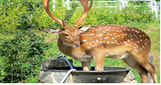
 | 8 | 
A dress with wings |  |  | A dress with wings |  | A dress with wings
An unreal person with wings |  |  | An unreal person with wings |  | An unreal person with wings
Run after |  |  | Run after |  | Run after
To go/give back. |  |  | To go/give back. |  | To go/give back.
To feel bad about not doing/doing something |  |  | To feel bad about not doing/doing something |  | To feel bad about not doing/doing something
A person who cuts wood for a job |  |  | A person who cuts wood for a job |  | A person who cuts wood for a job
A wild four legged animal which eats grass |  |  | A wild four legged animal which eats grass |  | A wild four legged animal which eats grass
A person who shoots wild animals |  |  | A person who shoots wild animals |  | A person who shoots wild animals

Answers

No. | Picture | Word | Definition
1 |  | Winged dress | A dress with wings
2 |  | Fairy | An unreal person with wings
3 |  | Chase | Run after
4 |  | Return | To go/give back.
5 |  | Regret | To feel bad about not doing/doing something
6 |  | Woodcutter | A person who cuts wood for a job
7 |  | Deer | A wild four legged animal which eats grass
8 |  | Hunter | A person who shoots wild animals

The Fairy and the Woodcutter

Once upon a time there was a woodcutter who lived on a mountain. He was poor but kind-hearted. And he lived with his mother.
One day, he saw a deer while he was cutting trees up in the mountain. A hunter was chasing the deer. The woodcutter hid the deer, and after a moment the hunter came up asking, "Have you seen a deer around here?" "No, I haven't." As soon as the hunter heard that, he left.

After a while, the deer came near the woodcutter saying, "Thank you very much. Please tell me one of your wishes. I will make it come true."

He said, "I want to have a wife." The deer said, "Then go to the pond, and you will see fairies. They're going to take a bath. Take the winged dress of one fairy. That fairy can't go back to heaven without her winged dress. And she will become your wife. However, there is one thing you should know. You must never return her dress until you have three children."
He did as the deer said. A fairy became the wife of the woodcutter. The days went by, and they had two children. But she still missed her home in heaven. The woodcutter was very sorry to see that. So, he gave back the dress.

Then, she held her two children under her arms and went back to heaven.

The woodcutter lived alone, missing his wife and children.

<Right Answers>
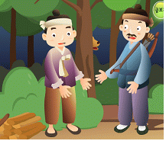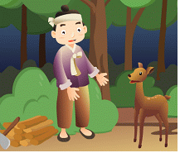
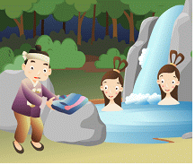
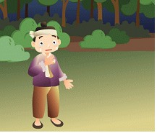

<Wrong Answers>
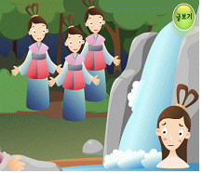
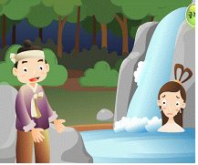

Virtual Interview!
ex. | 1) Reporter: Makes Questions.  2) Woodcutter & Fairy: Make Answers.  Q(Reporter): Sir, what’s your job?  A(Woodcutter): "I’m a woodcutter."  Q(Reporter): Who took your winged dress?  A(Fairy): The woodcutter took my winged dress.
1
2
3
4
5
Then, what will happen next?
✤ Think about the ending after the fairy went to back to heaven! Make up your own picture and story!
 | 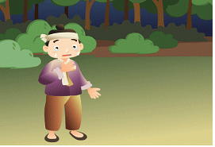

Sample Lesson 9: Ingyu's Camping Trip to Muju (Reading) pg. 102-104

Name: ____________________ Date: ____________ Teaching time: ___________________

Action points (These are the suggested techniques/ideas to try in your next practice teaching. See trainer's observation notes from your last practice teaching session and copy the action points here)

1. What are you teaching?
- Language points : Pick 6-8 of the following→ midnight, skit, creek, act out, fresh, dish, temple, prize, put up, in front of
- Language skills : reading
- Cultural Aspects :
2. What are your Student Learning Objectives for the lesson?
By the end of the lesson, SWBAT:

3. When/How in the lesson will I check students' progress toward the above Learning Objectives? What behaviors/activities will show me whether they have mastered the material? When the Ss answer the cloze activity and the questions about the text in the Jeopardy game.

Preliminary considerations:
a. What do your students already know in relation to today's lesson?

They might know the meaning of some words related to camping.
b. What aspects of the lesson do you anticipate your students might find challenging/difficult?

The lower-level Ss might have difficulty playing the Jeopardy game.
c. How will you avoid and/or address these problem areas in your lesson?
I’ll give clear directions for the game and I’ll let Ss work in groups to answer the Qs together before playing the Jeopardy game.

Steps | Stages | Time-  guess  here | Procedure/steps-these need to be written in the perspective of what the Ss do | Focus  S-S, T-S, etc | Activity Purpose
1 |  | 5 | * Ss look at the picture on pg. 96-97 and T elicits camping vocabulary.  * T writes words on WB  * T shows additional pictures and elicits more information about camping.  * T shows some pictures and Ss choose some items which are needed for camping. | S  Ss-T  S-S | Interest is generated. Ss schema is activated. Ss are treated as knowledgeable Ps.  T supports peer learning by writing elicited vocab on WB.  Ss are set up for successful reading by being introduced to the topic (camping).
2 |  | 8 | *Ss have a chance to look at the new vocabulary list and check the words that they already know and discuss the unfamiliar words with a partner.  *T goes over the FMU of 6-8 of the necessary vocabulary (midnight, skit, creek, act out, put up, dish, temple, in front of, fresh, prize) to understand the reading by providing the new words in context.  *T Asks Ss simple CCQs. Ex: “Is it dark or light out at midnight?” to check their understanding of new words. | S, S-S  T-Ss  T-Ss, Ss-T | Ss get a chance to teach each other the vocabulary (collaborative learning).  Vocab is pre-taught and Ss guess meaning through context so that Ss are set up to be successful at reading.
3 |  | 3 | *T shows the Q to the Ss:  - What is this story about?  *Ss read the Q all together.  *Ss tell their predictions to each other (partners or small group) | T-Ss  Ss  S-S | Prediction is used as a reading strategy.
4 |  | 3 | Ss read the text for 1 minute and find the answer to the Q and find out if their prediction is correct.  * Ss share their answer with a partner then with the whole class. | S  S-S  Ss-Ss | Ss are given a reason to read.  Ss are given a general and easy reading task.
5 |  | 12 | * Ss are given a fill-in-the-blanks sequence activity which is a summary of the story. Ss must fill in the blanks using "before” or “after" to show their understanding of the text.  * Ss read the text again.  * Ss fill in the blanks by themselves.  * Check the answers with the partners before checking with the whole class.  Option: For lower level Ss – pictures are used and Ss sequence the pictures before filling sequence a summary of the story. | S  S  S-S, Ss-Ss | Ss are given a reason to read.  Ss have a more specific and difficult reading task.
6 |  | 14 | *T gives a handout that includes Jeopardy Qs (Qs are based on comprehension of the reading text).  *Ss have a chance to answer the Jeopardy Qs together in their groups (4-5 minutes) by reading the text again and finding the answers.  * Ss play a Jeopardy game in groups  (*Note: To ensure all Ss have a chance to answer, T should make a rule that each S in each team must answer) | T-Ss  Ss-Ss  Ss-T | Ss show their comprehension of the text by playing a game.  Ss can learn from each other (collaborative learning)  T has a chance to check Ss progress towards achieving the SLO.

Sample Lesson 10: “Used to” pg. 185-188

Name: ___________________________ Date: __________________ Teaching time: _________________________

Action points – (These are the suggested techniques/ideas to try in your next practice teaching. See trainer’s observation notes from your last practice teaching session and copy the action points here).

1. ___________________________________________
2. ___________________________________________

1. What are you teaching?
- Language points – “What did you used to when you were younger?” “ I used to ______” “My classmate used to_______”
- Language skills – speaking and grammar
- Cultural Aspects – talking about things you used to do and finding out about what your classmates used to do

2. What are your Student Learning Objectives for the lesson? (These should be specific and describe observable student behaviors, which you will be able to see in class.)

By the end of the lesson, SWBAT:

- When/How in the lesson will I check students’ progress toward the above Learning Objectives? What behaviors/activities will show me whether they have mastered the material?

Preliminary considerations:
a. What do your students already know in relation to today’s lesson?
Ss can use past and present tense verbs; some Ss might know the meaning of “used to”.
b. What aspects of the lesson do you anticipate your students might find challenging/difficult?
Ss might have difficulty personalizing the use of “used to”.
c. How will you avoid and/or address these problem areas in your lesson?
I will give them examples that are related and interesting for Ss.

Steps | Stages | Time- guess  here | Procedure/Steps--these need to be written in the perspective of what the students do | Focus  S-S, T-S, etc. | Activity Purpose
1 |  | 5 | *Ss look at pictures and guess who the person is.  *T asks questions about the picture and Ss answer.  *T explains that Ss raise X and O cards for the statements (X=wrong, O=right) about the person.  *T models one example. *T goes over an easy example with the class to make sure they understand. *Ss do the activity.  i.e. “X” used to be a singer, but now she is an actress.  “Y” used to be a wrestler, but now “Y” is a talk show host. | Ss-T  T-Ss/Ss-T  T-Ss  T-Ss/Ss-T | T can access and assess Ss prior knowledge.  Ss discover the meaning and use of “used to” as T uses it an authentic way.  Ss can show their understanding by raising the O/X cards. It’s a visual, auditory, and kinesthetic activity.  Ss are active early in the lesson.
2 |  | 4 | *T gives examples and elicits “used to ” from Ss.  *T assess Ss understanding of the meaning by presenting an example and asking CCQs:  “I used to play soccer.”  Did I play soccer before?  Do I play soccer now?  Did I play soccer one time or more than one time?  Did you used to go to elementary school? What is something else you used  to do? | T-Ss  Ss-T  Ss | Ss need examples to understand the F/M of “used to”. Ss access prior knowledge and inductive process is used to discover grammar.
3 |  | 5 | *Ss do, “Match and Make the Sentences” activity and “Fill in the Blanks” activities in the textbook. (p186, p188). SARS maybe required to make the activities more meaningful  *Ss do the activities on their own.  *Ss check their answers with a partner by reading their answers aloud to each other.  *T elicits answers from Ss and T visually shows correct answers or Ss come to the board and draw lines between the correct answers and fill in the blanks. | Ss  S-S  Ss-Ss | T can check Ss understanding of FM with the textbook activities.  Ss check answers with peers to check errors together before doing it in front of the class to make the whole class activity safe for Ss.  Ss can learn from each other.  VA(K)T activity.
4 |  | 4 | * T models dialogue:  A: What did you used to do when you were younger?  B: I used to play the piano. (other examples are provided for the underlined part)  * T models first one with a S.  * Ss practice Q and A in a controlled manner. | T-Ss  T-S  S-S | Ss need an easy task to start off with and work on accuracy in an interactive and controlled way.
5 |  | 6 | * T shows the following support language on the screen.  A : What did you used to do when you’re younger?  B : I used to _______________________  *T elicits past experiences Ss did in the past but don’t do now and writes them on the board.  *Ss practice dialog with two different people and switch roles with each other.  *Ss choose another idea from the list and practice again with two different people. | T-Ss  Ss-T  S-S | Ss contextualize the exchange in authentic and personal situations and are given a reason to listen to each other.  Ss get a chance to practice the dialog with different partners.
6 |  | 6 | *Ss write 1-3 sentences that state what they did when they were younger.  *T elicits the Q from the Ss before they begin speaking.  *Ss then ask and answer each other using their own statements. | Ss  Ss-T  S-S | Ss further personalize the activity.  Writing is added as a skill.  The support language is gradually taken away.  Ss are active.
7 |  | 8 | *T passes out a sheet of paper with 16-20 activities and asks Ss to check which of these activities they used to do when they were younger.  *T hands out blank grid. Ss copy the shortened sentences randomly into the worksheet (NOT in order.)  * T goes over “Find Someone Who” activity to make sure that Ss understand what to do.  *T give the directions about “Find someone who ……” activities verbally and visually.  NB: This is an adaptation of Bingo, but Ss must ask their friends “what did you used to do?” and elicit an answer (in the TL: “I used to ____.”) The first S will then put that S’ name into the appropriate box on the grid. When a S has 4 in a row, they can shout “bingo.” The teacher will then take the paper and ask the Ss named on the grid, “did you used to ____?” If all the answers are valid, that S is the winner.  NB: Ss can give different answers to different Ss about what they used to do when they were younger. This might prolong the game  Note: The square with the S’ own name is immediately filled in.  *T models the activity with a S.  *T has 2 Ss model the activity.  *Ss survey and write down the information on the worksheet.  Adaptations: If there are less than 15 Ss, extra squares can be designated “free” according to how many Ss are absent. For additional practice, Ss can play Four corners or Black Out versions where the four corners or all spaces must be covered, respectively. | T-Ss  Ss  T-S  S-S  S-S | T prepares Ss for the activity.  Ss have a chance to use “used to” in a meaningful and personalized way.  This is a VA(K)T activity.  Ss are active.

Bingo
Free

Can you think of a better fluency activity? Share your ideas with your peers and your trainer.

Sample Lesson 11 – Reading3 – “Passive” (Missing Parts)

Name: ____________________ Date: / / Teaching time: ______________________

Action points – (These are the suggested techniques/ideas to try in your next practice teaching. See trainer’s observation notes from your last practice teaching session and copy the action points here)
1. Give Ss strategies to help them read more effectively.
2. Many chances for the students to show comprehension of the text.

1. What are you teaching?

Language points – 1st page: emperor, century, symbol, wealth, invention 2nd page: frame, fall off/fell off, decision, secret, trial
- Language skills – reading
- Cultural Aspects – eyeglasses and their historical and cultural significance

2. What are your Student Learning Objectives for the lesson? (These should be specific and describe observable student behaviors, which you will be able to see in class.)

By the end of the lesson, SWBAT:

- When/How in the lesson will I check students’ progress toward the above Learning Objectives? What behaviors/activities will show me whether they have mastered the material?

Preliminary considerations:
a. What do your students already know in relation to today’s lesson?

b. What aspects of the lesson do you anticipate your students might find challenging/difficult?
Trusting their peers to give them all the information they’ll need.

c. How will you avoid and/or address these problem areas in your lesson?
Make sure the Ss understand their responsibility to their peers in transferring their understanding of the reading.

Steps | Stages | Time- guess here | Procedure/Steps--these need to be written in the perspective of what the students do | Focus  S-S, T-S, etc. | Activity Purpose
1 |  | 2 | * Ss name all the things on pg.156 with a partner (pre-listening activity). | S-S
2 |  | 3 | * Do pg. 156 - “Listen and Match I” - listening for the purpose of why things were invented.  * Ss check answers with each other. | S  S-S
3 |  | 2 | * Ss look at the picture on pg 160 and predict the story.  * Ss write down or tell their partner their prediction. | S  S-S
5 |  | 6 | * Ss are introduced to vocab that will help them in reading the story:  1st page: emperor, century, symbol, wealth, invention  2nd page: frame, fall off/fell off, decision, secret, trial  * Ss first get a chance to describe the words to each other in pairs.  * T helps with any that are still unclear. | T-Ss  S-S  T-Ss
6 |  | 3 | * Ss practice with stress and sounds on pg. 164 (some of the words they’ll see in the story). | Ss
7 |  | 10 | * Ss are split into two groups.  * One group reads pg. 160 the other group reads pg. 161.  *T chunks directions and checks each chunk with specific CCQs: Are your papers the same or different?  * Ss are reminded that they will have to tell the others what they read and also T give Ss reason to read.  * Ss can be encouraged to take notes and check their understanding with guided/mind mapping worksheet.  *Ss are encouraged to use the TL.  Optional: For lower level Ss, T may want to provide Ss with a graphic organizer Wh-Q sheet: who, what where, when…, a comic book style pictorial summary, sentence prompts: “Eye glasses were invented in…” or some other support strategy to support Ss in the task of summarizing their reading and then an info gap activity to support Ss in sharing their information | S | .
8 |  | 9 | *Ss are re-grouped Ss who read pg. 160 pair with an Ss who read p. 161.  *Ss exchange information about the two texts; T may want to support Ss through providing an info gap activity  * After Ss exchange info, they each answer True/False questions (see pg. 161 for example Qs) to check their understanding of the whole text.  * Ss check answers with their partner for accuracy. | S-S  S-S  S-S
9 |  | 3 | * Ss go to pg. 164 –“Useful Expressions” - and read the expressions used in context within the sentences.  * Ss do “Fill in the blanks”.  * Ss check their answers with each other. | S  S  S-S
10 |  | 4 | * Ss brainstorm things they use in their daily lives.  * Ss write sentences using the words they brainstormed with the passive voice. T writes on board:  “__________ was invented by_________”.  * Whatever the Ss don’t finish in class they can do for homework. | Ss-T  S

Sample Lesson 12 - Speaking and Grammar – “Active and Passive” (Missing Parts)

Name: ___________________ Date: / / Teaching time:____________

Action points – (These are the suggested techniques/ideas to try in your next practice teaching. See trainer’s observation notes from your last practice teaching session and copy the action points here)
1. 2.

1. What are you teaching?
- Language points – Active and Passive voices and “Can you tell me~ ?” and “Do you know who~ ?”
- Language skills –
- Cultural Aspects --

2. What are your Student Learning Objectives for the lesson? (These should be specific and describe observable student behaviors, which you will be able to see in class.)

By the end of the lesson, SWBAT:

3. When/How in the lesson will I check students’ progress toward the above Learning Objectives? What behaviors/activities will show me whether they have mastered the material?

Preliminary considerations:
a. What do your students already know in relation to today’s lesson?
b. What aspects of the lesson do you anticipate your students might find challenging/difficult?
Making sure that they use the passive appropriately and not just focus on correctly forming sentences.
Getting away from the habit of simply changing active sentences into passive sentences without acknowledgement of meaning or use.
c. How will you avoid and/or address these problem areas in your lesson?
Make sure to introduce the function of passive along with the correct form and give Ss chances to practice with it.

Steps | Stages | Time- guess  here | Procedure/Steps--these need to be written in the perspective of what the students do | Focus  S-S, T-S, etc. | Activity Purpose
1 |  | 2 | * Ss open their books to pg. 157 - “Listen and Answer.”  *Ss read the two Qs before they listen.  *Ss share answers with a partner, and then share with whole class. | S  S  S-S,  Ss-T
2 |  | 5 | * Ss do pg. 157 - “Sounds”- to practice intonation of Qs.  * T elicits three other inventions and writes on the board.  * Ss practice asking the question “Do you know….” Using the words on the board and using the right intonation. | T-Ss  Ss-T  S
3 |  | 2 | * Ss do pg 155 – “Look and Match”.  * Ss check their answers with a partner and share with the whole class. | S  S-S,  Ss-T
4 |  | 2 | Pg. 156 - “Listen and Match II”  *Ss look at pictures.  *Have Ss predict what they might hear.  *T previews listening Qs with Ss and then Ss listen and answer the questions.  *Ss check their answers with e/o, and then T checks answers with whole class. | S  S  S-S
5 |  | 6 | Pg. 158 – “Look and Say I”  *T models the example.  *T models the first one with a S.  *Ss ask and answer the questions in pairs.  Pg. 158 - “Work in Pairs”  * Ss fill in Q and A on “Can you tell me who…”  Optional: Ss can also practice using “Do you know who…” | T-Ss  T-S  S-S  S-S
6 |  | 4 | * Ss play a quick game with verb flashcards to refresh their memories on past participles in pairs.  (T has verbs in the root base form written on cards and Ss have to give the past participle form to their partner: T presents examples and has Ss notice difference between active and passive - using the verbs listed on page 163 would be a good idea). | S-S
7 |  | 2 | Pg. 163 – “Structures”  * Ss do the activity by completing the sentences.  * Ss share their answers with a partner and then with the whole class. | S  S-S,  Ss-T
8 |  | 3 | Pg. 165 – “Let’s Write”  * Ss do exercises A and B and check their answers with a partner.  Optional: For lower level Ss, T may need to give the base form of the verb. | S, S-S
9 |  | 5 | Optional: If Ss need additional work with form - pg. 169 - “Your Choice”  *Ss unscramble the sentences and check answers with a partner. | S  S-S
10 |  | 4 | *T intros the idea of when and why the passive is used. T writes some examples on the board:  When you want to focus on the thing or product and not the doer.  When you don’t need to mention who did it or it is understood. | T-Ss
11 |  | 6 | T facilitate Ss to come up with something, for example realia in the classroom(e.g., a coin, a stapler, a pop song, etc.) to elicit the passive by asking the Ss:  “Do you know when this ____ was made?”  Ss answer: “No, I don’t.” or “Yes, it was made in ____.”  T can then ask: “Who made it?”  Ss can answer: “It was made by _____.” or “I don’t know who made it.” | T-Ss  Ss-T

Possible final fluency dialog
A: Do you know who……. B: Yes, it was _____ by _____ or No, can you tell me who …..? A: Yes, sure. It was _____ by _____.

Sample Lesson 13 - Speaking and Grammar – “Are you sure?” (Missing Parts)

Name: __________________ Date: / / Teaching time: __________________

Action points – (These are the suggested techniques/ideas to try in your next practice teaching. See trainer’s observation notes from your last practice teaching session and copy the action points here)
1.
2.

1. What are you teaching?
- Language points – Are you sure? Yes, I’m sure , passive using “by statements”
- Language skills – speaking and grammar
- Cultural Aspects – checking understanding or credibility

2. What are your Student Learning Objectives for the lesson? (These should be specific and describe observable student behaviors, which you will be able to see in class.)

By the end of the lesson, SWBAT:

3. When/How in the lesson will I check students’ progress toward the above Learning Objectives? What behaviors/activities will show me whether they have mastered the material?

Preliminary considerations:
a. What do your students already know in relation to today’s lesson?

b. What aspects of the lesson do you anticipate your students might find challenging/difficult?
The Ss may have trouble with the directions.

c. How will you avoid and/or address these problem areas in your lesson?
I will write down the directions so the Ss can follow both my voice and the visual.

Steps |  | Time- guess  here | Procedure/Steps--these need to be written in the perspective of what the students do | Focus  S-S, T-S, etc. | Activity Purpose
1 |  | 6 | Pg. 157 – “Listen and Answer”  *Ss look at the pictures and guess who the person is.  *Ss read the questions and then listen for the answer.  *Ss check answers with a partner and share their answers with the whole class. | Ss-T  S  S-S,  Ss-T
3 |  | 5 | Pg. 159 – “Look and Say II”  * T models dialogue.  * T models first one with a S.  * Ss practice Q and A in a controlled manner. | S-S
4 |  | 5 | Pg. 159 – “Work in Pairs”  *T models the dialogue in the box with a S and switches A & B roles.  *Each S writes their own sentence for number 3.  *Ss practice the dialogues in pairs with the “Are you sure?” response. | T-S  S  S-S
5 |  | 8 | *T puts the following support language on the board:  A: _________________________________.  B: Are you sure?  A: Yes, I’m sure.  B: Wow/OK, _______________. Or Wow/ok, I’ll do it/that.  Option 1: T can provide statements for Ss to use in the dialog.  Example: It’s important to take vitamins with your meals.  Option 2: T can elicit similar statements from Ss and write them on the board.  *Ss practice dialog with two different people and switch roles with each one. | T-Ss  T-Ss  Ss-T  S-S
6 |  | 3 | Review of passive: Ss do quick review past and past participles. | S-S
7 |  | 5 | *T elicits how to form the passive from Ss (be+ past participle).  *T elicits or explains why passive is used in speech (because the do-er is not necessary to mention or is understood by the listener).  *T explains when the use of “by” IS important (For example: when the speaker wants to include who did the action in the passive sentence). | Ss-T  Ss-T  T-Ss  T-Ss
8 |  | 8 | *In pairs Ss change 3-4 active voice sentences (provided by the teacher) into passive voice sentences. Ss should add in the “by” statement when appropriate.  For example: Teachers usually know all their students’ names.  Ss might answer: All the students’ names are usually known by the teacher.  (“by” is needed to indicate who knows the names)  OR  Ss speak only in English in class.  Only English is spoken in class.  (“by the students” is not needed because the doer (students) is understood in this context)  *NOTE:  Avoid using statements in the passive voice such as:  My book is read by me everyday.  (Active voice is more appropriate: I read my book everyday.)  OR  Speaking is practiced by her everyday.  (Active voice is more appropriate: She practices speaking English everyday.) | S-S  T-Ss
9 |  | 4 | * With their partner Ss practice these passive sentences and add on “Are you sure?” and “Yes, I’m sure.” | S-S

Lesson Plan 14: What’s in the Ads? (Reading) pg 144-145

Name: ______________ Date: / / ____ Teaching Time: _________________

Action points – (These are the suggested techniques/ideas to try in your next practice teaching. See trainer’s observation notes from your last practice teaching session and copy the action points here)
1. What are you teaching?

- Language points – vocabulary specific to the reading—listed in the lesson plan
- Language skills – reading
- Cultural Aspects – how advertisers get you interested in their products

2. What are your Student Learning Objectives for the lesson? (These should be specific and describe observable student behaviors, which you will be able to see in class.)
By the end of the lesson, SWBAT:
Show comprehension of the text by answering questions about the text using the target vocabulary and identifying the advertising technique in each ad.

3. When/How in the lesson will I check students’ progress toward the above Learning Objectives? What behaviors/activities will show me whether they have mastered the material?
Preliminary considerations:
a. What do your students already know in relation to today’s lesson?
b. What aspects of the lesson do you anticipate your students might find challenging/difficult?
Trusting their partners to give them all the information they’ll need from all the sections of the reading to succeed with activities
c. How will you avoid and/or address these problem areas in your lesson?
Make sure Ss understand that their peers are relying on them to explain their section clearly
Sample Lesson 15 – Reading – “Holidays in the Fall” – Pg. 182~192

Name: __________________ Date: / / Teaching time: _____________

Action points – (These are the suggested techniques/ideas to try in your next practice teaching. See trainer’s observation notes from your last practice teaching session and copy the action points here)
1.
2.

1. What are you teaching?
- Language points –

- Language skills – reading

- Cultural Aspects – sharing about holidays around the world

2. What are your Student Learning Objectives for the lesson? (These should be specific and describe observable student behaviors, which you will be able to see in class.)

By the end of the lesson, SWBAT:

Demonstrate an understanding of the text by answering detailed comprehension questions. Optional Post Activity <If time permits, SWBAT: Talk about a Korean holiday by telling a classmate how they would explain a Korean festival to a foreigner.>

3. When/How in the lesson will I check students’ progress toward the above Learning Objectives? What behaviors/activities will show me whether they have mastered the material?
Ss will answer the detailed comprehension questions using the target vocabulary and present to a small group how they’d explain a Korean festival to a foreigner.

Preliminary considerations:
a. What do your students already know in relation to today’s lesson?

b. What aspects of the lesson do you anticipate your students might find challenging/difficult?

c. How will you avoid and/or address these problem areas in your lesson?
Sample Lesson 16 — Speaking and Grammar — “Present Perfect” — Pg. 186, 191

Name: ________________ Date: / / Teaching time:_____________

Action points – (These are the suggested techniques/ideas to try in your next practice teaching. See trainer’s observation notes from your last practice teaching session and copy the action points here)
1.
2.

1. What are you teaching?
- Language points –

- Language skills – grammar and speaking

- Cultural Aspects –sharing past experiences

2. What are your Student Learning Objectives for the lesson? (These should be specific and describe observable student behaviors, which you will be able to see in class.)

By the end of the lesson, SWBAT:

Show the ability to use the present perfect appropriately when asking and answering questions using the following: “What have you done in your life?” or “What have you done before?” “I’ve _______.” “You have?! So have I!” or “Not me, I’ve never _____.” by finding 2 classmates who they’ve shared an experience with.

3. When/How in the lesson will I check students’ progress toward the above Learning Objectives? What behaviors/activities will show me whether they have mastered the material?
When the Ss have found at least 2 people who they’ve shared and not shared an experience with and when Ss are able to report back to the class with support from the teacher with the phrase: “Both __ and I have _______.” and “___ has _____ but I haven’t.”
Preliminary considerations:
a. What do your students already know in relation to today’s lesson?

b. What aspects of the lesson do you anticipate your students might find challenging/difficult?

c. How will you avoid and/or address these problem areas in your lesson?
Sample Lesson 17 —Speaking and Grammar — “Relative Clauses” - Pg. 186

Name: _____________ Date: / / Teaching time:_____________

Action points – (These are the suggested techniques/ideas to try in your next practice teaching. See trainer’s observation notes from your last practice teaching session and copy the action points here)
1.
2.

1. What are you teaching?
- Language points –

- Language skills – speaking and grammar

- Cultural Aspects –

2. What are your Student Learning Objectives for the lesson? (These should be specific and describe observable student behaviors, which you will be able to see in class.)

By the end of the lesson, SWBAT:

Demonstrate the ability to identify and form sentences with [which/who] clauses by combining sentences and/or adding extra information to a basic sentence about a subject.

3. When/How in the lesson will I check students’ progress toward the above Learning Objectives? What behaviors/activities will show me whether they have mastered the material?
Ss will show an ability to form relative clauses by adding extra information to basic sentences or combining two sentences.

Preliminary considerations:
a. What do your students already know in relation to today’s lesson?

b. What aspects of the lesson do you anticipate your students might find challenging/difficult?

c. How will you avoid and/or address these problem areas in your lesson?
Sample Lesson 18— Speaking — “Time” — Pg. 181

Name: _________________ Date: / / Teaching time: _________________

Action points – (These are the suggested techniques/ideas to try in your next practice teaching. See trainer’s observation notes from your last practice teaching session and copy the action points here)
1.
2.

1. What are you teaching?
- Language points – 1) “What time is it?” “What time does….” and/or “What time do you…” 2) “It’s ____.” “It’s at….” and/or “I …. at….” 3) half, quarter, to and past
- Language skills – speaking
- Cultural Aspects –

2. What are your Student Learning Objectives for the lesson? (These should be specific and describe observable student behaviors, which you will be able to see in class.)

By the end of the lesson, SWBAT:

Demonstrate the ability to ask and answer questions about time: “What time is it?” “What time does….” and/or “What time do you…”and answer with: “It’s ____.” “It’s at….” and/or “I …. at….” by doing a mingle activity.

3. When/How in the lesson will I check students’ progress toward the above Learning Objectives? What behaviors/activities will show me whether they have mastered the material?
Ss will ask each other questions about when they do the activities listed on page 181 - “Work in Pairs” - and respond to each other accurately when a time is displayed on a clock and they are asked the Q: “What time is it?” Ss will do a mingle activity with no support language to show mastery.

Preliminary considerations:
a. What do your students already know in relation to today’s lesson?

b. What aspects of the lesson do you anticipate your students might find challenging/difficult?

c. How will you avoid and/or address these problem areas in your lesson?
Sample Lesson 19: Lion in Love & The Fox and the Crane

Name: _________________ _ Date: __________________________ Teaching time: 45 minutes

Action points – (These are the suggested techniques/ideas to try in your next practice teaching. See trainer’s observation notes from your last practice teaching session and copy the action points here)
1.
2.

1. What are you teaching?
- Language points –1st: ask for, upset, prove, claws, 2nd: crane, make fun of, pitcher

- Language skills – reading

Cultural Aspects –

- What are your Student Learning Objectives for the lesson?

By the end of the lesson, SWBAT:

3. When/How in the lesson will I check students’ progress toward the above Learning Objectives? What behaviors/activities will show me whether they have mastered the material?

Preliminary considerations:

b. What aspects of the lesson do you anticipate your students might find challenging/difficult?

c. How will you avoid and/or address these problem areas in your lesson?

Lion in Love
In the forest, a lion saw a woman. She was very beautiful. The lion fell in love. So he followed her home. When the lion got to the woman’s home, he asked the father for his daughter.

“I want to marry your daughter,” said the lion.

The father thought, “I can’t say no. He is too dangerous. I can’t upset him. But I also can’t give my daughter to him. What must I do?”

Then he had an idea, and he spoke to the lion: “Alright. If you love her, you can marry her. But you must prove your love. You must lose your teeth and claws. Can you do that?”

“Surely I can do that,” answered the lion.

The lion went away and came back without his teeth and claws. The lion asked for the daughter again. But this time the father was not afraid. So he took a stick and drove the lion away.

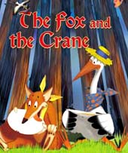Fox and Crane

In the forest, there lived a fox and a crane. The fox didn’t like the crane. The crane acted gentle and graceful, and the fox didn’t like that. The fox wanted to make fun of the crane. So the fox invited the crane to dinner.

At dinner time the fox gave the crane some soup. But the soup was on a flat dish. The fox, of course, could eat it easily. But the crane could not.

The fox thought it was funny. The crane saw the smile on the fox’s face. Now he knew why the fox had invited him. He was angry, but he didn’t show his anger. Instead, he invited the fox to dinner.

This time the crane put the food in a pitcher with a long neck. Of course the crane could eat it easily. But the fox could not.

Sample Lesson 20 — Speaking — “Phone Calls” — Pg. 180

Name: ____________________ Date: / / Teaching time: _________________

Action points – (These are the suggested techniques/ideas to try in your next practice teaching. See trainer’s observation notes from your last practice teaching session and copy the action points here)
1.
2.

1. What are you teaching?
- Language points –

- Language skills – speaking

- Cultural Aspects – how to use the phone appropriately and invite someone to do something

2. What are your Student Learning Objectives for the lesson? (These should be specific and describe observable student behaviors, which you will be able to see in class.)

By the end of the lesson, SWBAT:

Demonstrate an ability to make plans on the phone appropriately using the following language: “Can I speak to _____?” “This is he/she.” “Can you (verb)_____?” ”Yes, I can__”/”No, I can’t ___” and “Sounds great.”/”That’s too bad.” by having a phone conversation with their partner.

3. When/How in the lesson will I check students’ progress toward the above Learning Objectives? What behaviors/activities will show me whether they have mastered the material?
Ss will use these expressions in a conversation while they role play calling and inviting a peer to do something.

Preliminary considerations:
a. What do your students already know in relation to today’s lesson?

b. What aspects of the lesson do you anticipate your students might find challenging/difficult?

c. How will you avoid and/or address these problem areas in your lesson?
Lesson Plan Form – 21 : Ingyu’s Camping Trip to Muju Pg103

Name: ______ Date: ________ Teaching time: ________________
Action points – (These are the suggested techniques/ideas to try in your next practice teaching. See trainer’s observation notes from your last practice teaching session and copy the action points here).

1.
2.

1. What are you teaching?
- Language points –hiking, top of the mountain, take a rest, curry and rice, campfire, before, after

- Language skills – listening

2. What are your Student Learning Objectives for the lesson? (These should be specific and describe observable student behaviors, which you will be able to see in class.)

By the end of the lesson, SWBAT: demonstrate an understanding of the listening text by answering detailed comprehension check questions.

3. When/How in the lesson will I check students’ progress toward the above Learning Objectives? What behaviors/activities will show me whether they have mastered the material?
When Ss circle what they hear, put pictures in order, answer T/F questions, and fill in the blanks while listening to the passage.

Preliminary considerations:
a. What do your students already know in relation to today’s lesson?
Some Ss might have background of the key vocabulary such as hiking, before, after, and campfire

b. What aspects of the lesson do you anticipate your students might find challenging/difficult?
Describing their own experience.

c. How will you avoid and/or address these problem areas in your lesson?
By showing Ss a model passage.
By encouraging them to cooperate in group.

Sample Lesson 22— Pronunciation — Pg.187

Name: _______________ Date: / / Teaching time: ______________

Action points – (These are the suggested techniques/ideas to try in your next practice teaching. See trainer’s observation notes from your last practice teaching session and copy the action points here)
1.
2.

1. What are you teaching?
- Language points –
- Language skills – speaking and pronunciation
- Cultural Aspects –

2. What are your Student Learning Objectives for the lesson? (These should be specific and describe observable student behaviors, which you will be able to see in class.)

By the end of the lesson, SWBAT:

Identify where to place the stress on selected words and differentiate between the sounds /z/ and /s/ and /i/ and /e/ by marking the stress on words and holding up a card that corresponds to that sound.

3. When/How in the lesson will I check students’ progress toward the above Learning Objectives? What behaviors/activities will show me whether they have mastered the material?
When the students can place the stress marks accurately over the syllable that is stressed.
When they hold up a card that relates to the sound when it’s heard (For example: they have two cards, for the minimal pair /s/ and /z/ and they indicate what they heard by holding up the card).
Preliminary considerations:
a. What do your students already know in relation to today’s lesson?

b. What aspects of the lesson do you anticipate your students might find challenging/difficult?

c. How will you avoid and/or address these problem areas in your lesson?

Sample Lesson 23— “Used to” — Pg.186, 188

Name: _______________ Date: / / Teaching time: ______________

Action points – (These are the suggested techniques/ideas to try in your next practice teaching. See trainer’s observation notes from your last practice teaching session and copy the action points here)
1.
2.

1. What are you teaching?
- Language points –
- Language skills – speaking and grammar
- Cultural Aspects –

2. What are your Student Learning Objectives for the lesson? (These should be specific and describe observable student behaviors, which you will be able to see in class.)

By the end of the lesson, SWBAT:

Demonstrate the ability to ask and answer Qs using the following: “What did you used to do when…?” “I used to_____” and “My classmate used to__” BY do a survey of their classmates and presenting what they learned.

3. When/How in the lesson will I check students’ progress toward the above Learning Objectives? What behaviors/activities will show me whether they have mastered the material?
Preliminary considerations:
Ss will say one thing that they heard a peer say: “My classmate used to ___” and follow it with “and I used to ____” Ss then change partners to pass on the information about their former partner to a new partner.

a. What do your students already know in relation to today’s lesson?

b. What aspects of the lesson do you anticipate your students might find challenging/difficult?

c. How will you avoid and/or address these problem areas in your lesson?

